General tips for the Task below.
Task Title
Load Balancer
Objective
Worked on pre-requisite, as I watched the Load Balancer posted in DevOps group in slack and task to work on below.
Prerequisites
List all requirements before starting:
- AWS
Issues Faced: Briefly mention issues and how you fixed them. Posted below in the last.
Conclusion
Conclusion has been provided for every task at the end.

Load Balancer Tasks

- Configure Classic Load balancer.
Objective:
To distribute incoming traffic across multiple servers using a Classic Load balancer for High availability and Scalability.
CLB is best for simple applications which need basic HTTP/HTTPS or TCP port configurations to load balancer, health checks or SSL termination.
Prerequisites:
• VPC and 2 subnets in 2 different availability zones.
• 2 EC2 instances with 2 subnets attached
• Security groups and load balancer traffic allowing traffic for port 80.
• Health check endpoint configure for ec2 instances.
  - SSL certificate if required for secure port (HTTPS/SSL)
  - IAM role (if logs or s3 access required)
Step by Step implementation:
Step 1: Navigate to VPC and create a VPC
Created with a CIDR range- 198.162.0.0/20
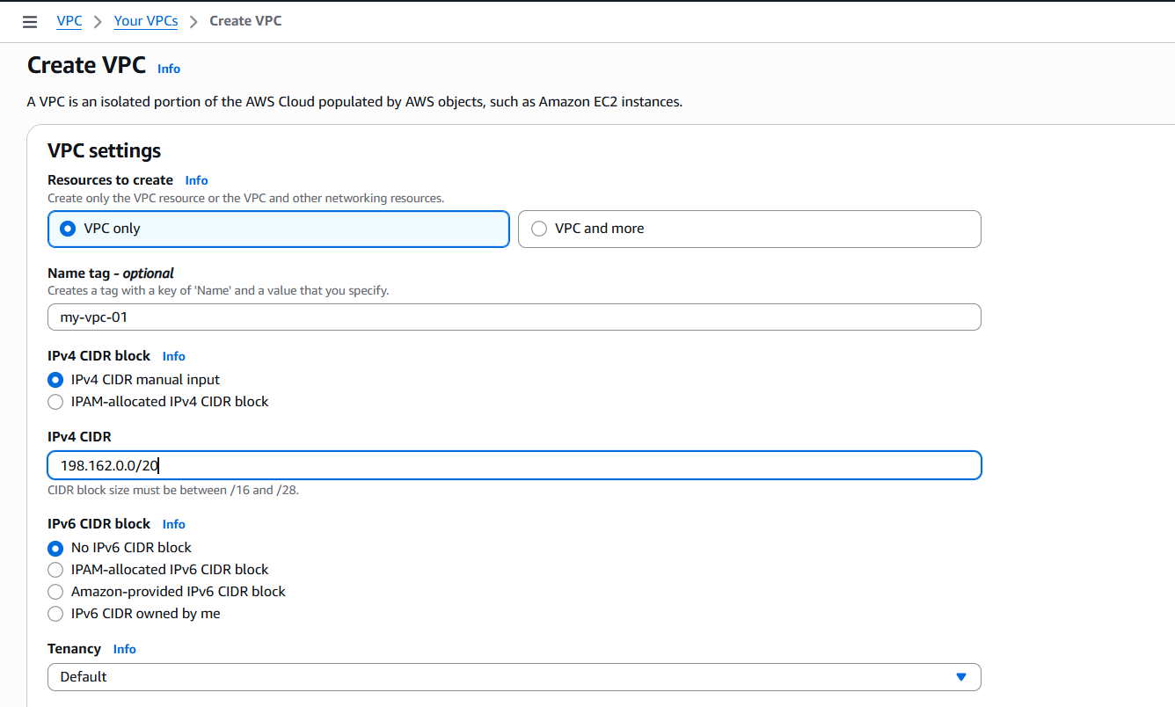
- VPC created successfully.

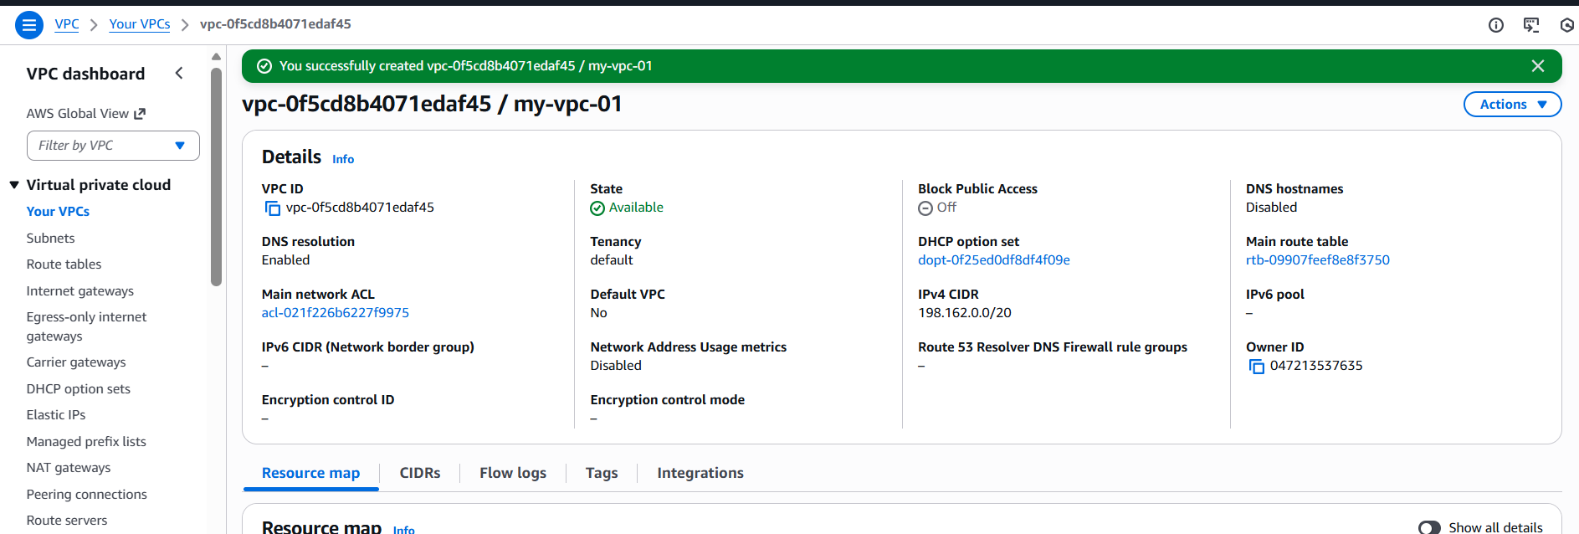

Step 2: Now, lets create 2 subnets in 2 different availability zones.
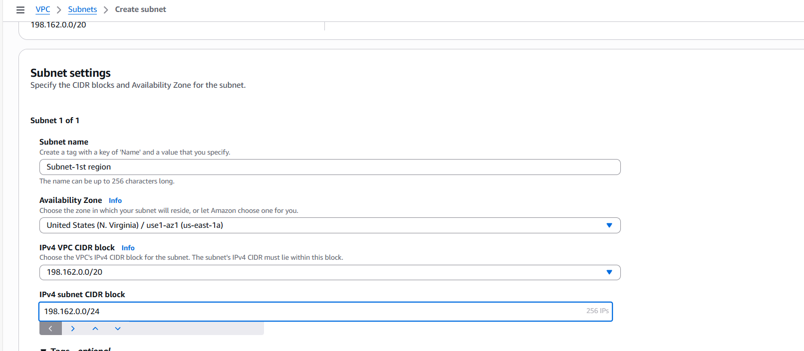

- Subnet created in us-east-1 availability zone.
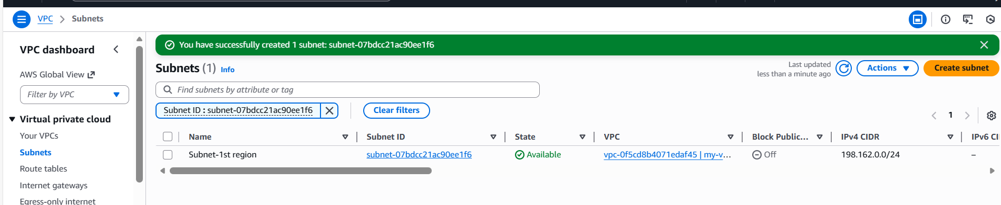

- Let’s create 2nd subnet in 2nd availability zone.

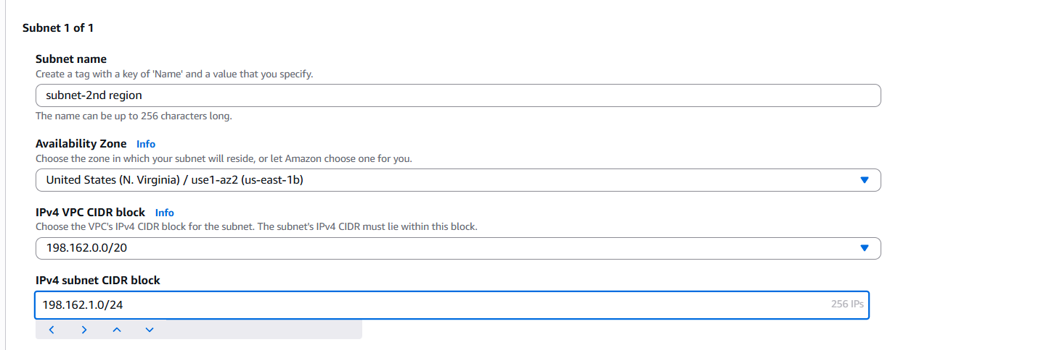

- 2nd Subnet created successfully in us-east-2.

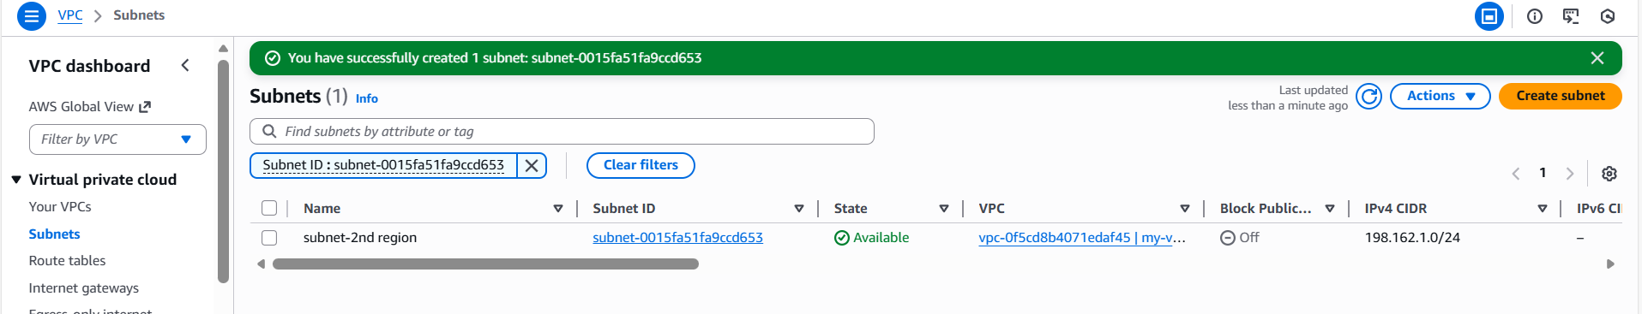

Step 3: Now, lets create a Internet Gateway
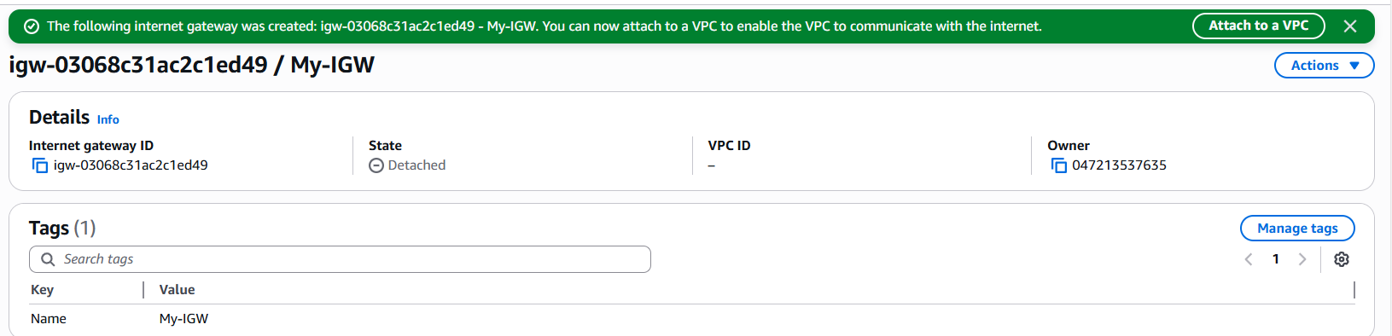

- Let’s attach VPC to the IGW

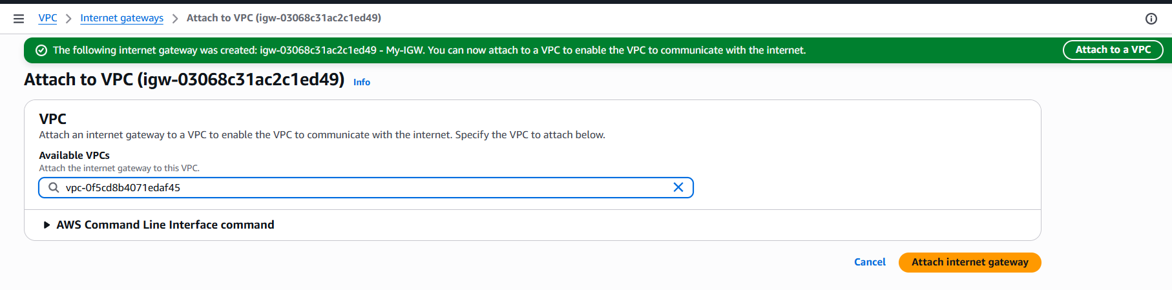

Step 4: Let’s create a route table and attach the IGW.

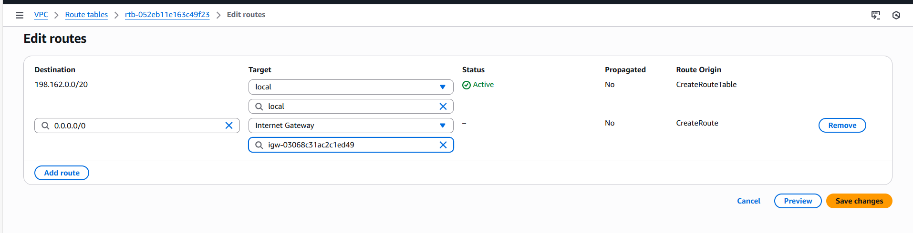

Step 5: Now attach the subnets to get internet access.
Attached subnets to the route table to get internet access.

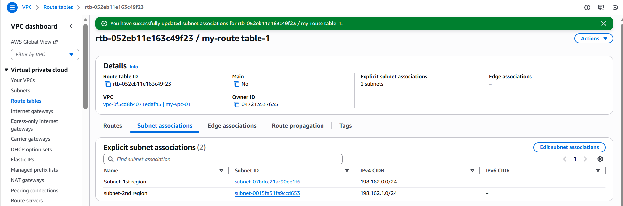

Step 6: Let’s create 2 ec2’s and attach subnets created.

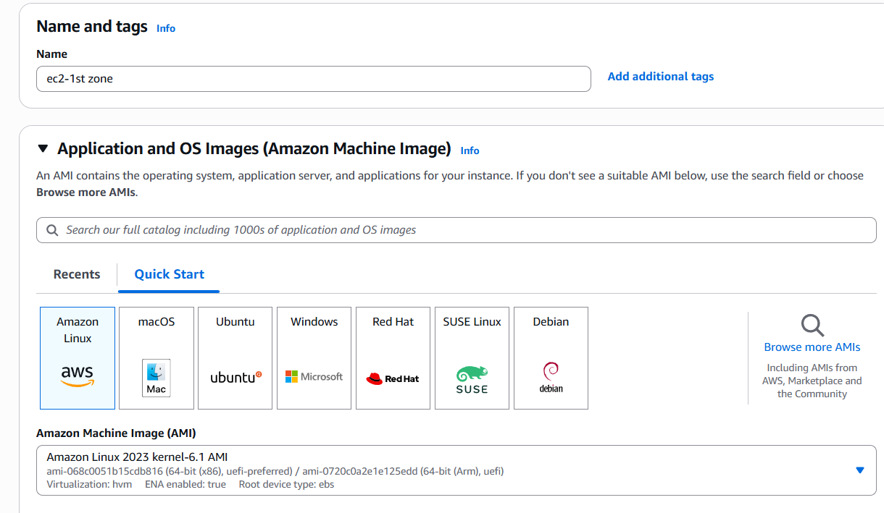

- Attached VPC and subnet created for 1st availability zone.
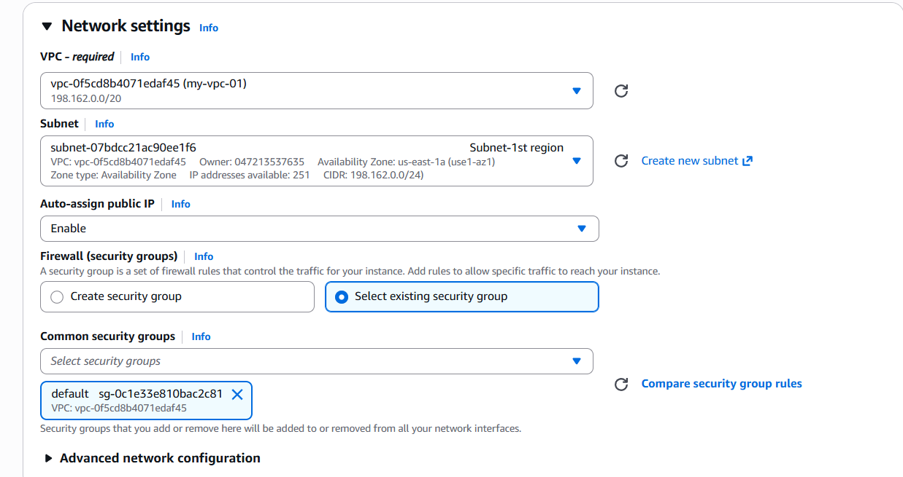

- To install httpd on launching the instance, updated the script to enable Apache.

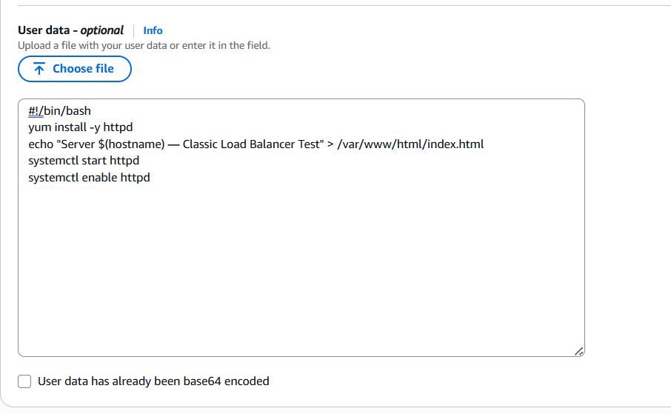

- Successfully launched the 1st instance.
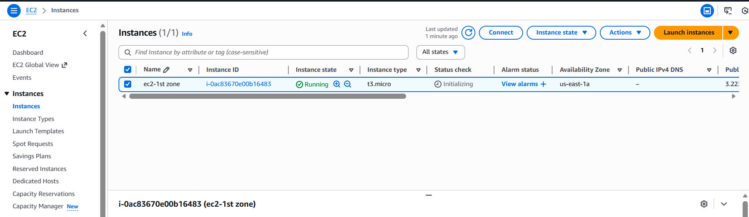
- Now, lets launch the second instance with 2nd subnet in second availability zone.
- Second Instance launched successfully with User Data updated to launch Apache application on default.
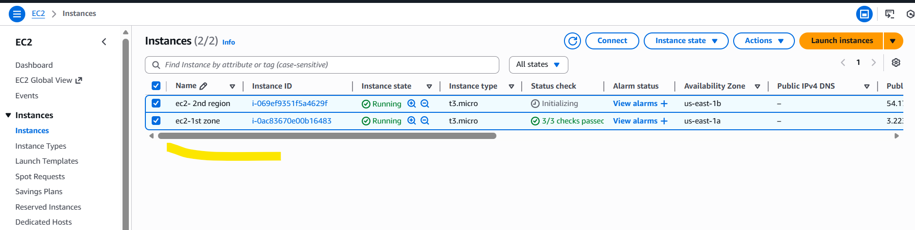

Step 7: Let’s update Security groups to those instances.
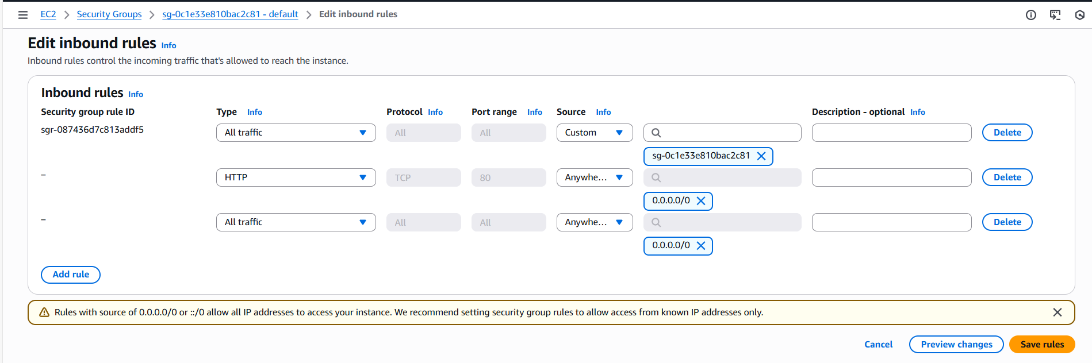
- Updated Security groups to second instance as well to allow- http and all traffic.

Step 8: Launched 1st instance to verify if Apache is installed and running.
Success, its running as expected.

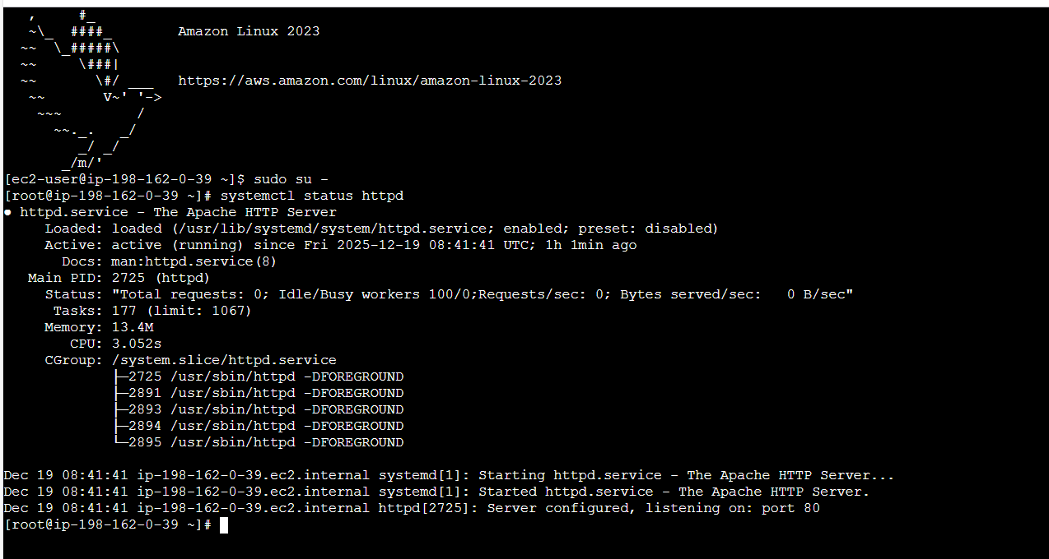

- Verified on browser and its working as expected.
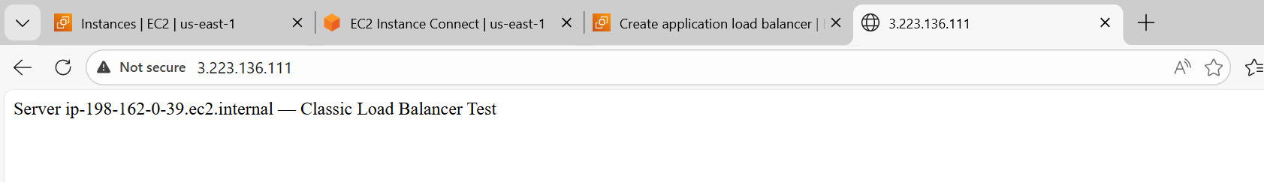

Step 9: Let’s verify the second instance by connecting to server.
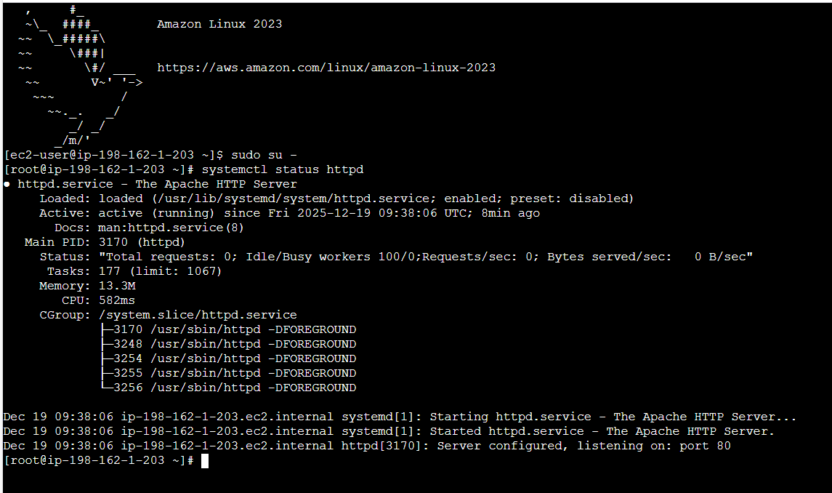

- Verified on browser and its working as expected.

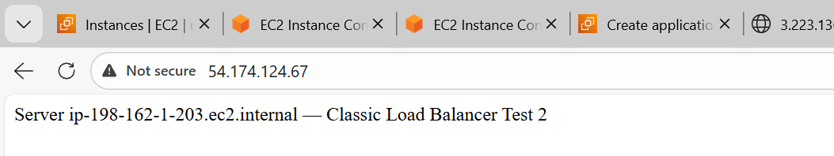

Step 10: Its time to launch the Load balancer as we are all set with VPC Instances httpd server created.
Navigate to ec2 Create load balancer
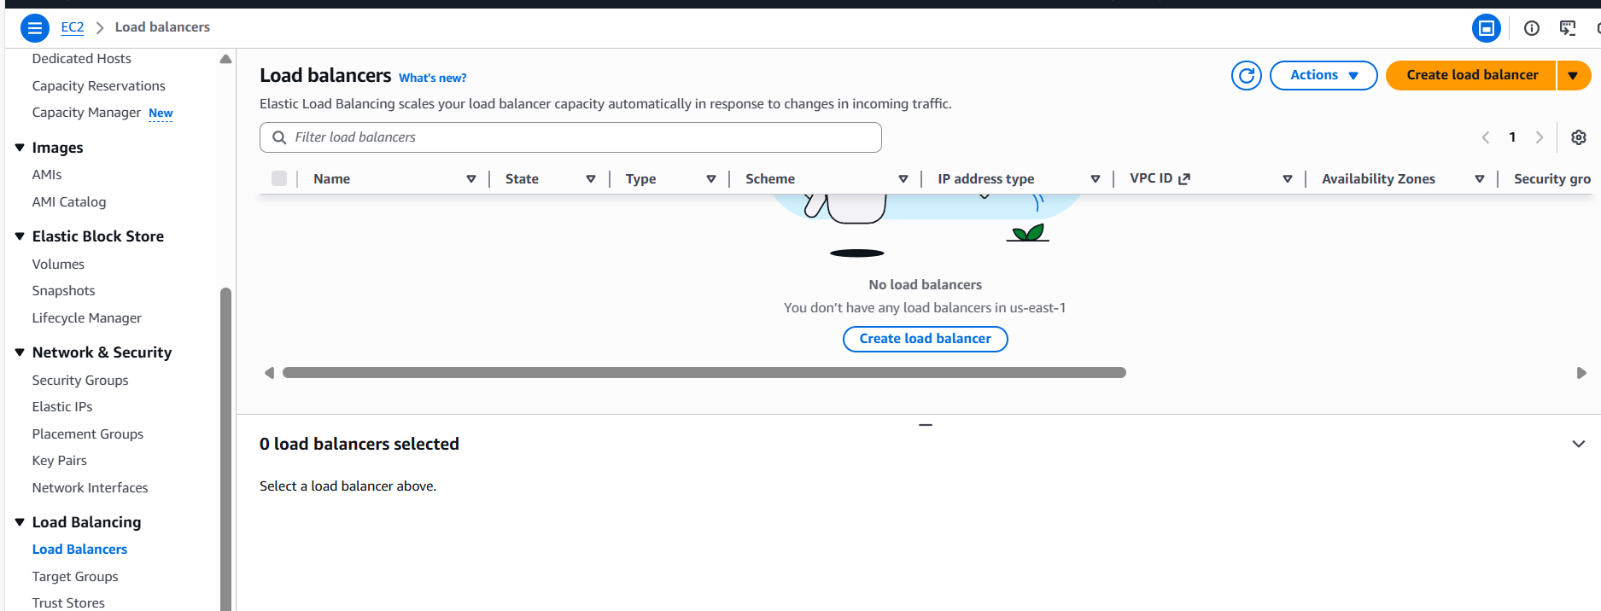
- Creating Classic Load Balancer for my requirement.
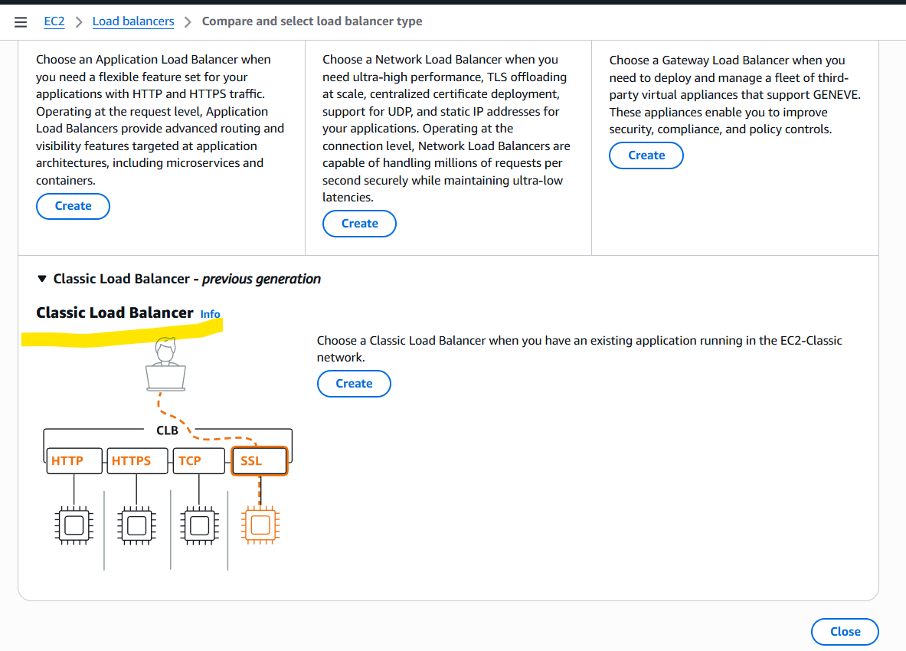
- Load balancer name is created and scheme is updated to “Internet-facing”
- Updated VPC and subnets attached to two different zones.
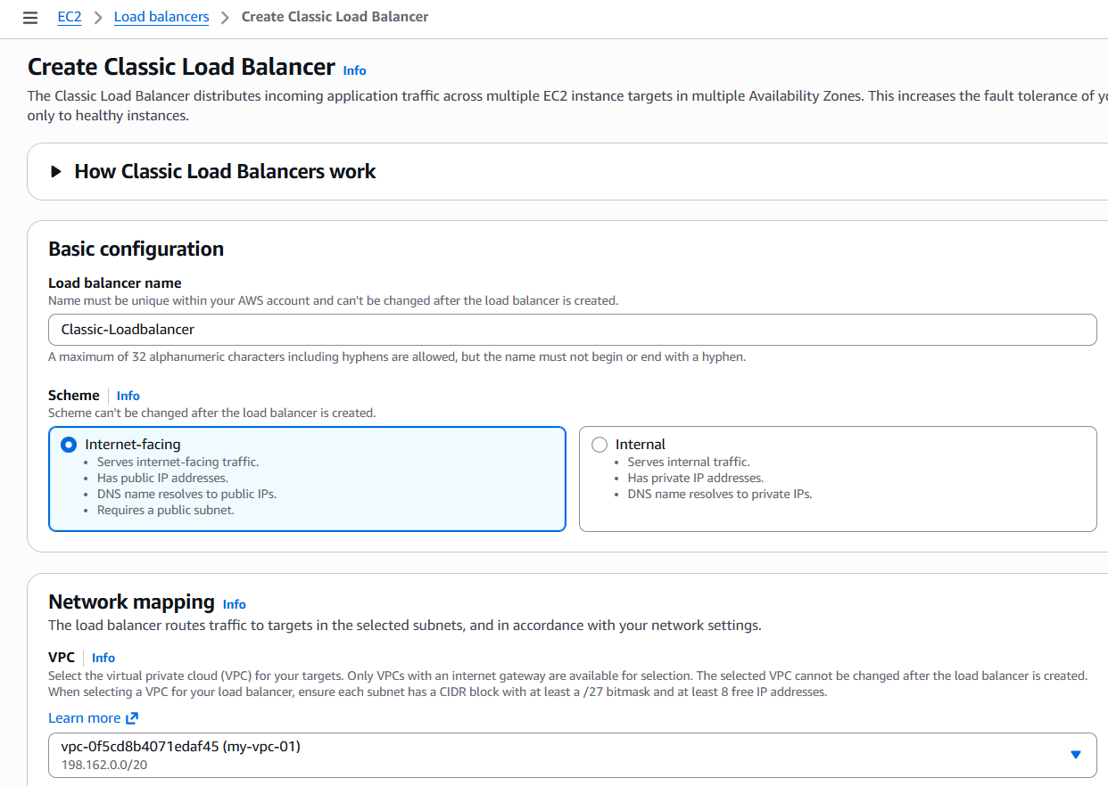
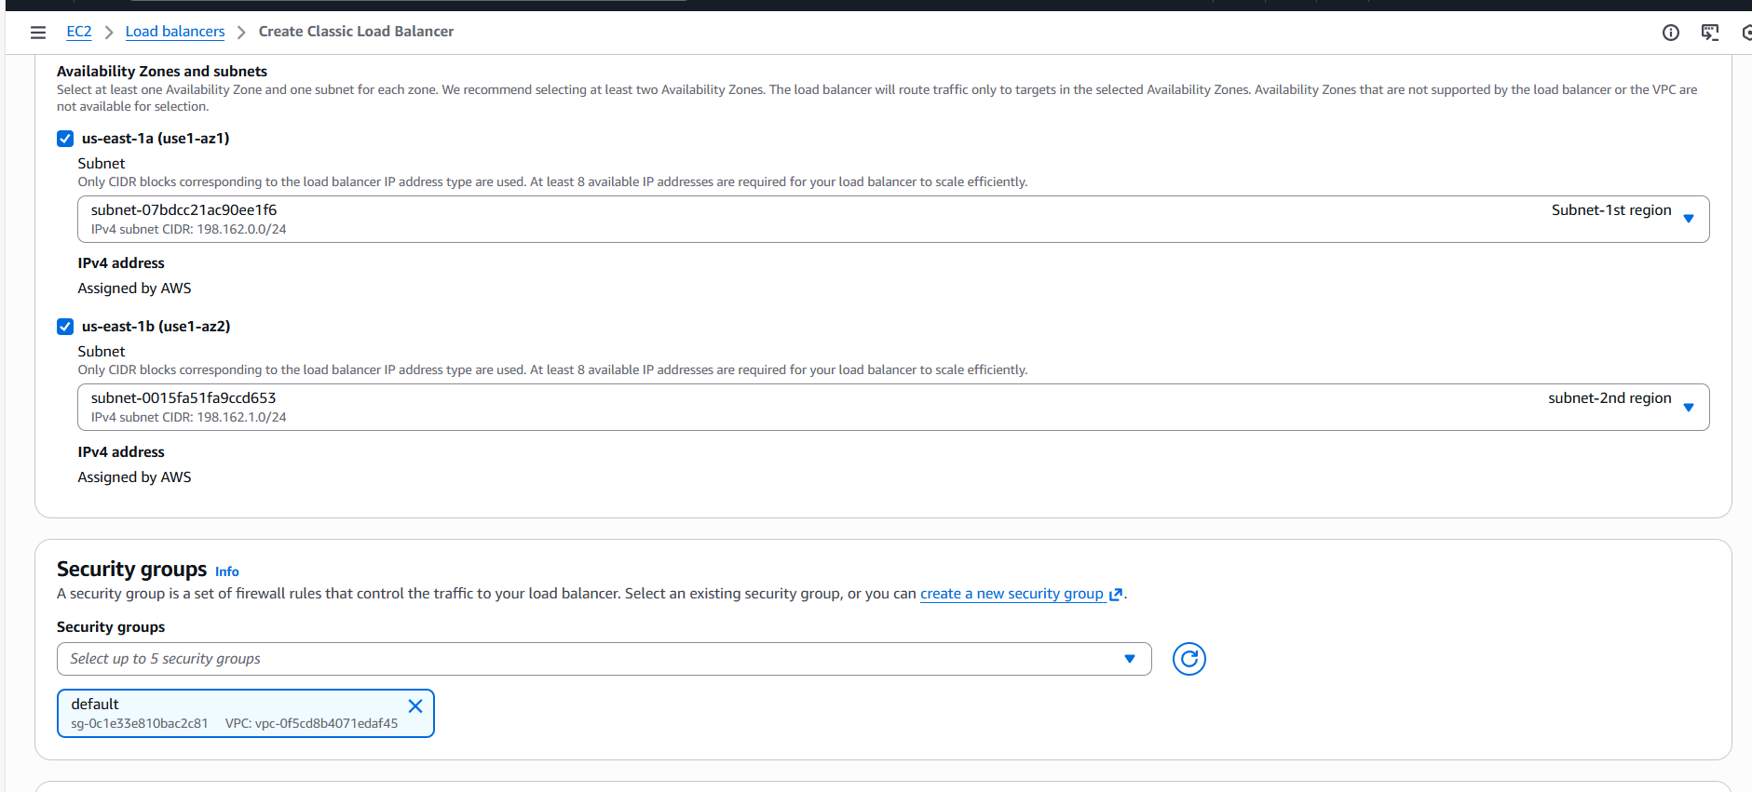
- Updated listeners according to the Apache package.
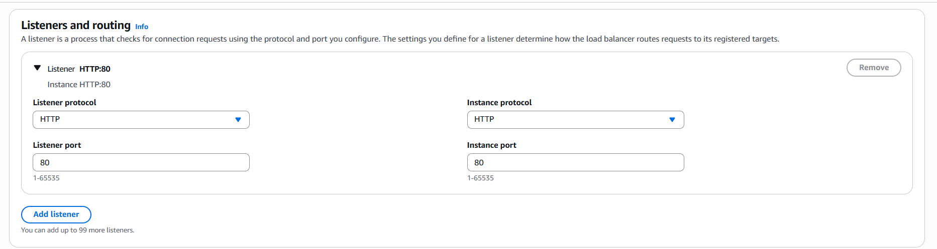
- Selected the Health path as per the Apache package.
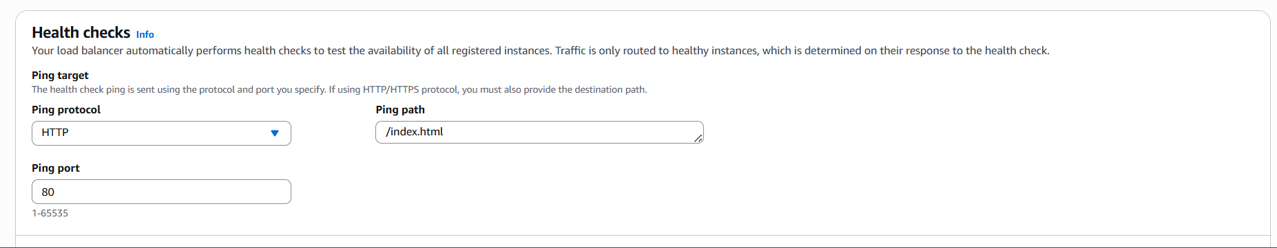

- Attached 2 instances and we can see its running as expected.
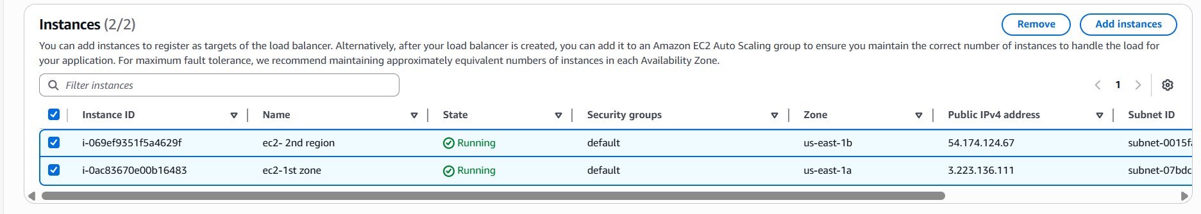

- Select the Attributes timing and continue to the final step.
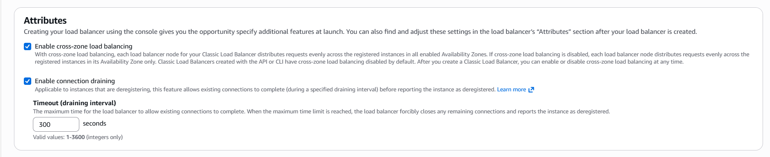
- Review the summary and create Load balancer.
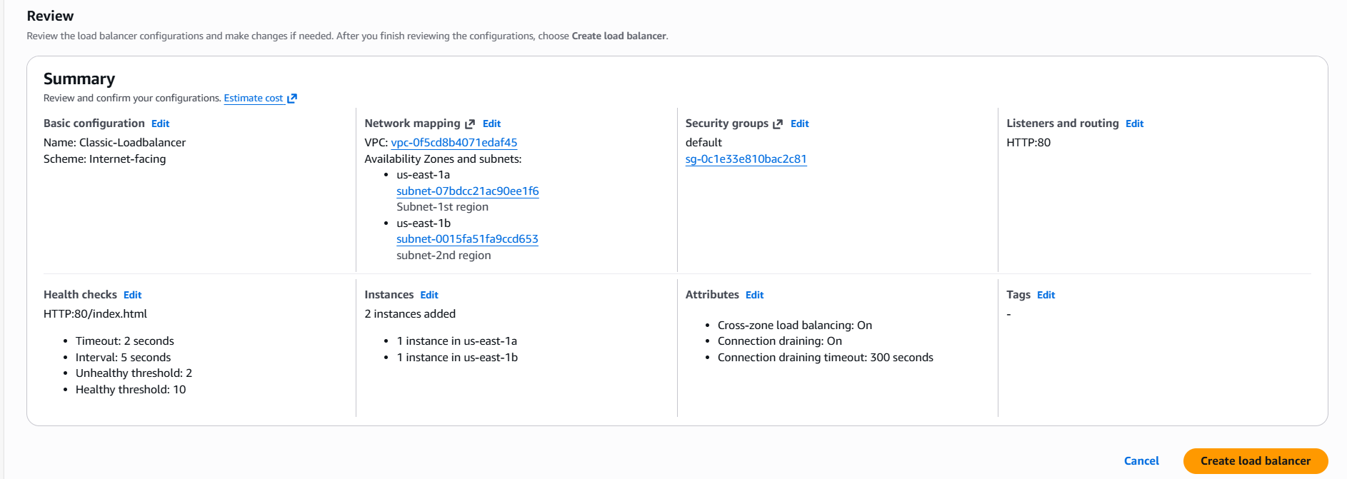

- Classic Load balancer created successfully.
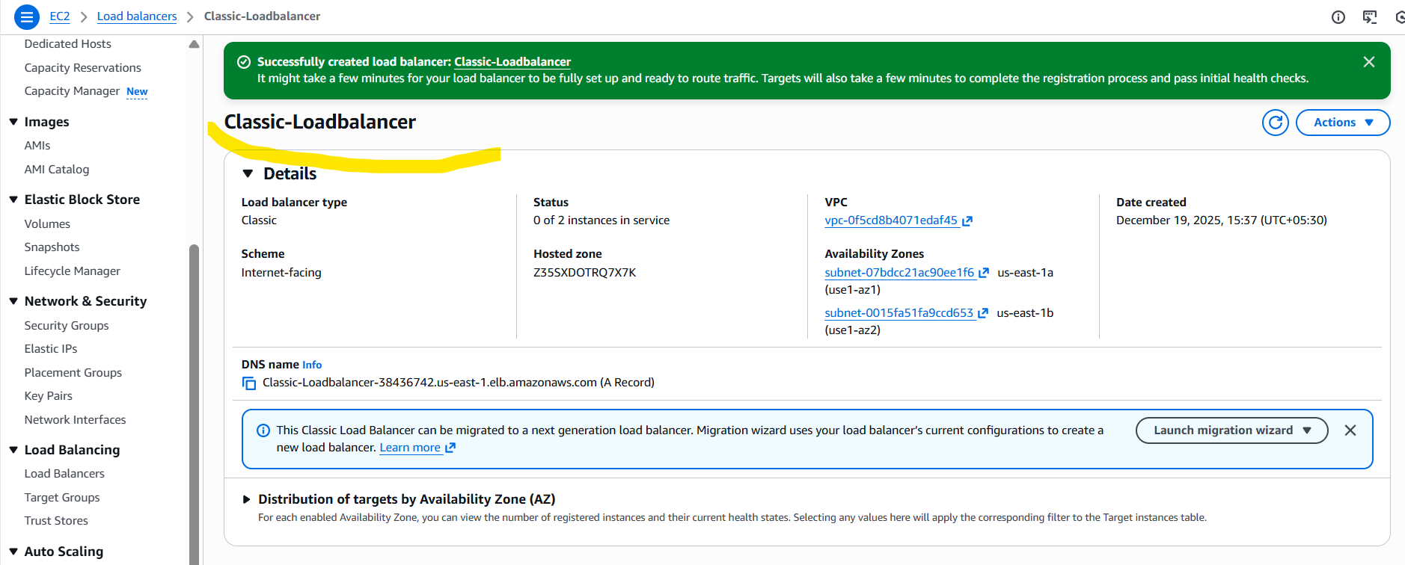
- Health checks are active and Healthy, so that, we can 2 instances are running successfully and traffic is distributes evenly.
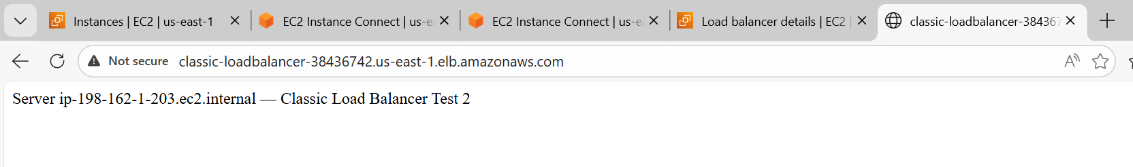

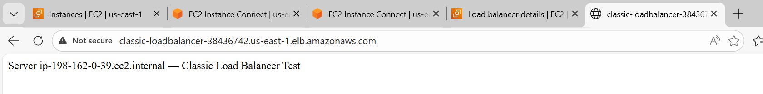

Conclusion:

Classic Load balancer is a simple and older version of distributing traffic to the servers. This is used in a old fashion way and the negative part of Classic LB is we used have equal instances in availability zones.

- Configure Network Load balancer.

Objective:
The objective of Network Load Balancer is to distribute incoming traffic at low latency and high performance using OSI model- Layer 4 (Transport layer).
The speciality of this LB is it can handle en number of users to access the website within seconds with high availability.

Prerequisites:
- VPC and 2 subnets in 2 different availability zones.
- EC2 instances (we have installed Apache earlier in CLB with same Port-80)
- Network Load balancer
- Target group to be created for UDP/TCP traffic
- Security groups on ec2 instances allowing 80 port traffic.
- Elastic Ips if static Ips required
- Health checks endpoint for TCP/HTTP/HTTPS.

Step by step Implementation:
Step 1: Earlier in the Classic Load balancer, we created a VPC, 2 ec2S, 2 subnets in 2 different regions.
So, we shall go ahead and create a network load balancer.
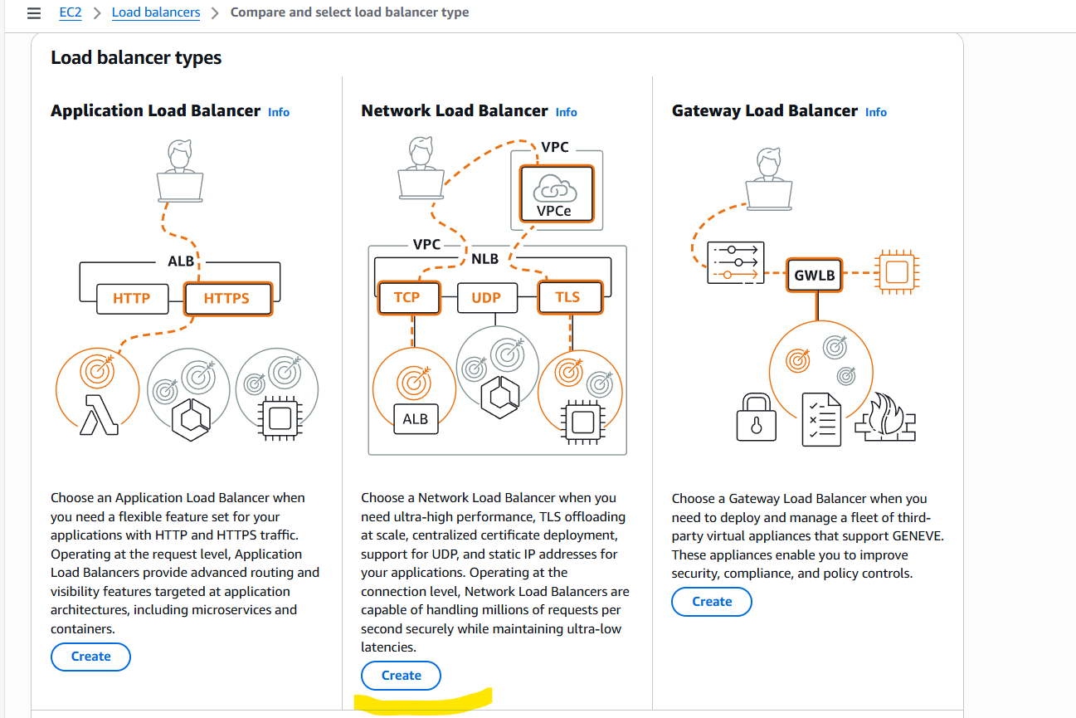

- Provide a name to the Load balancer and scheme will be Internet facing.
- IP address type will be IPV4.
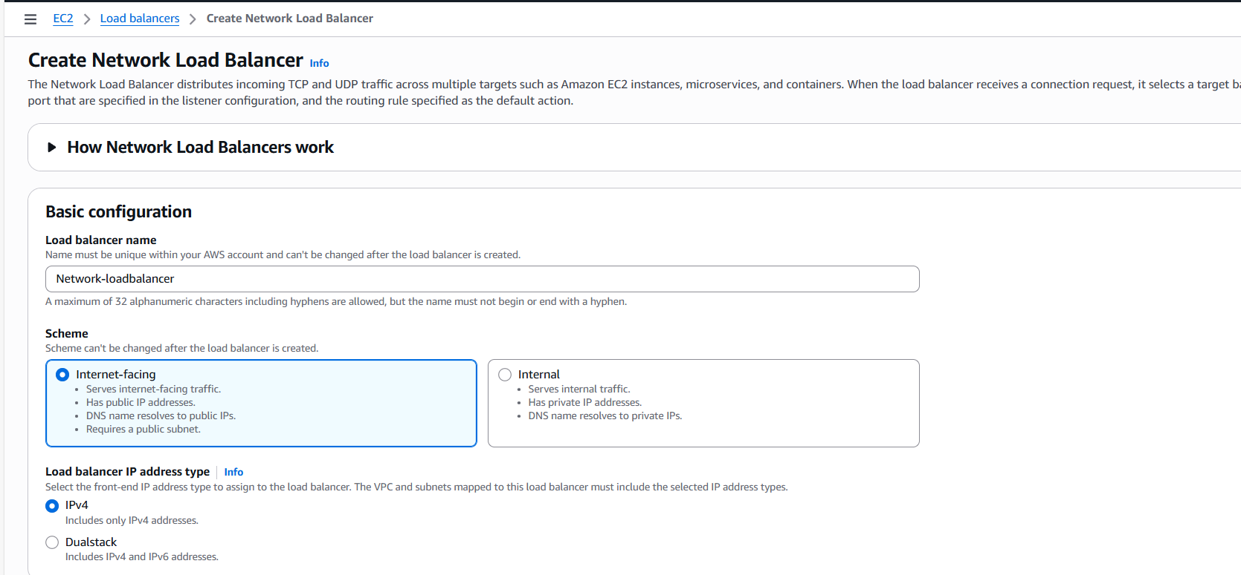
- Attached VPC and 2 subnets from 2 availability zones.
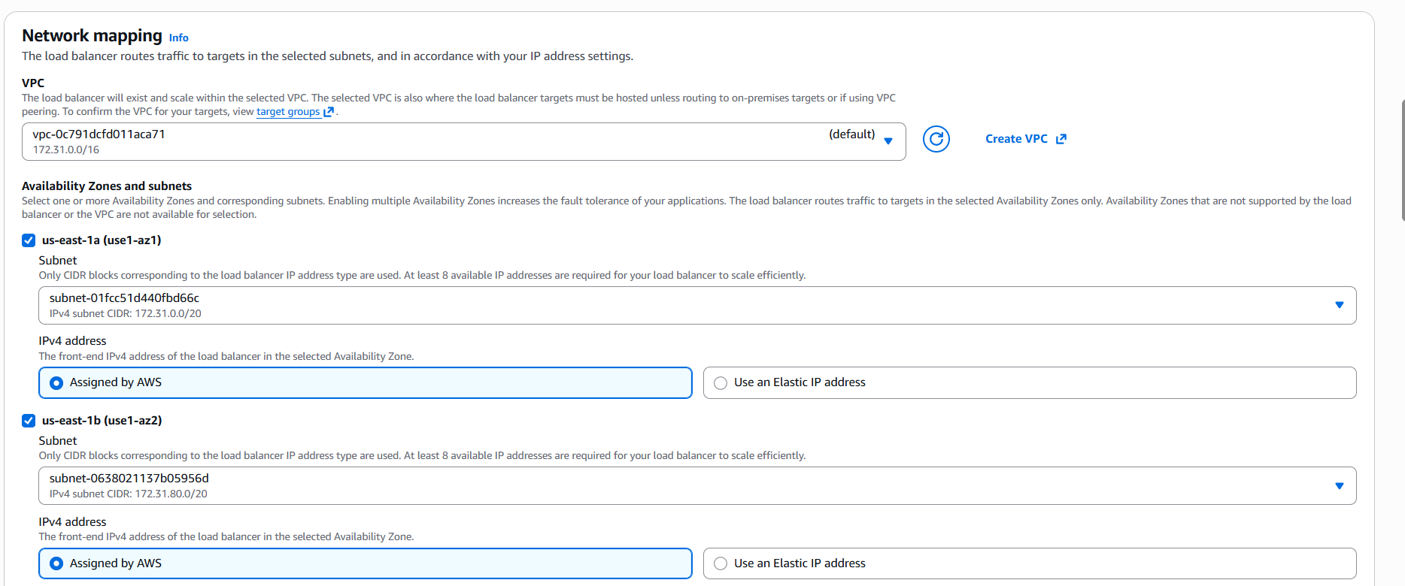
- We need to provide listeners for the application to hear in the port. We provided TCP/80.
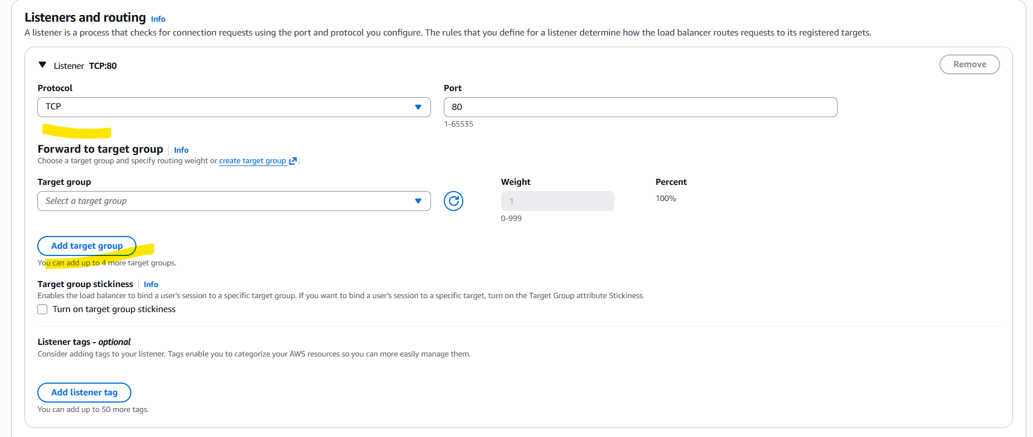
- Now, we need to add Target groups to work closely with Load balancer and servers to verify Heath checks and re-routing to other instances as per traffic demand.
Step 2:
- Provided name for the Target group and protocol selected as TCP/80.
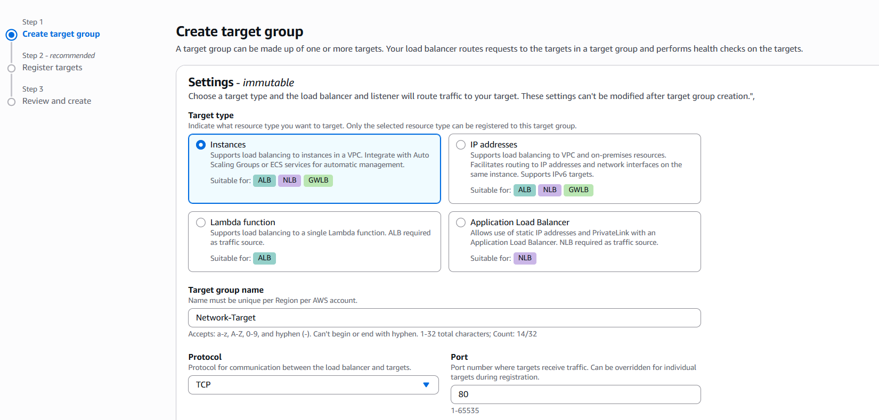
- Attached VPC and Health checks path can be attached.
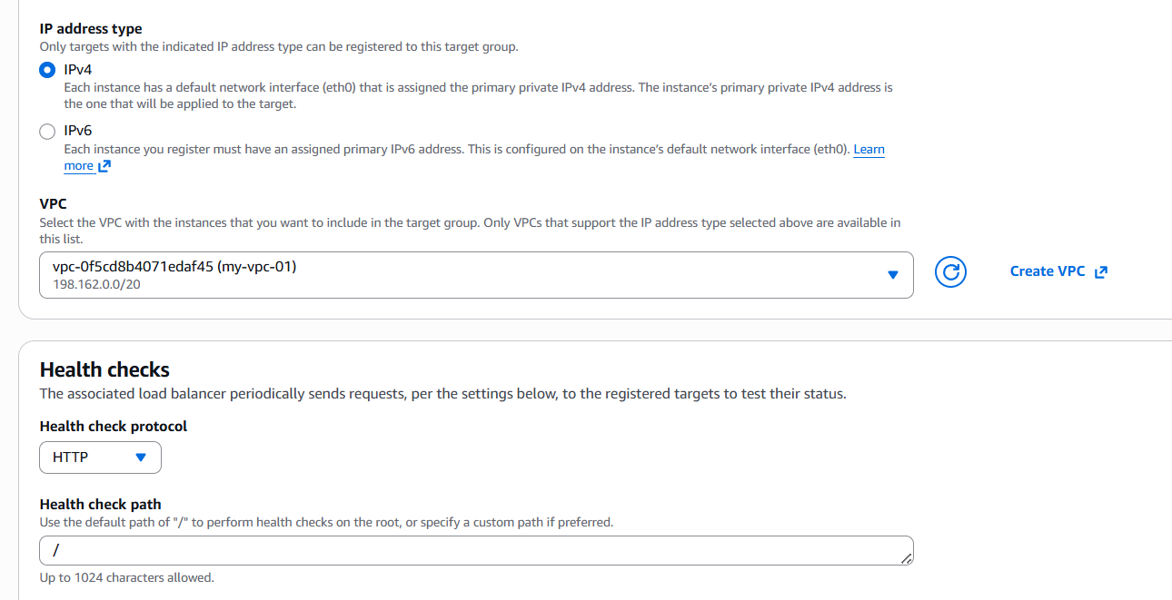

- Health check port should work as per below configurations.
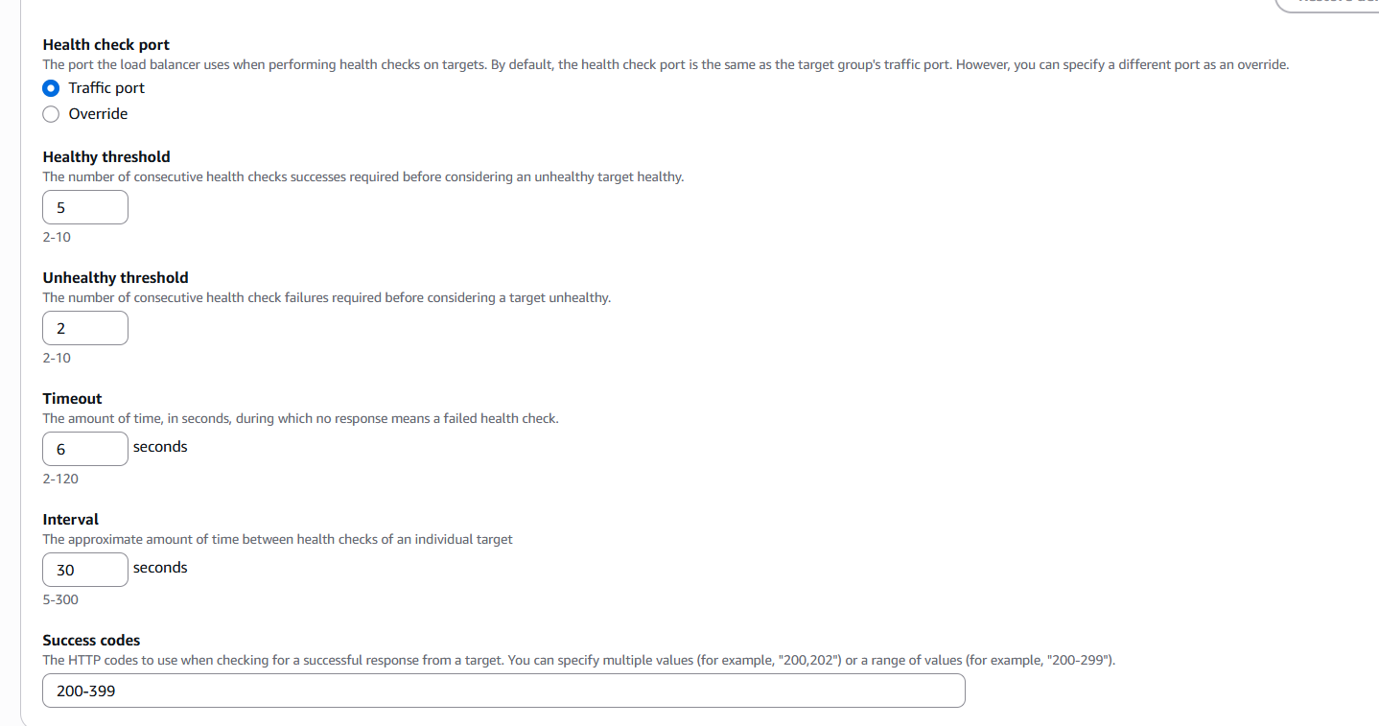

- Selected the two instances running and marked as pending as well.
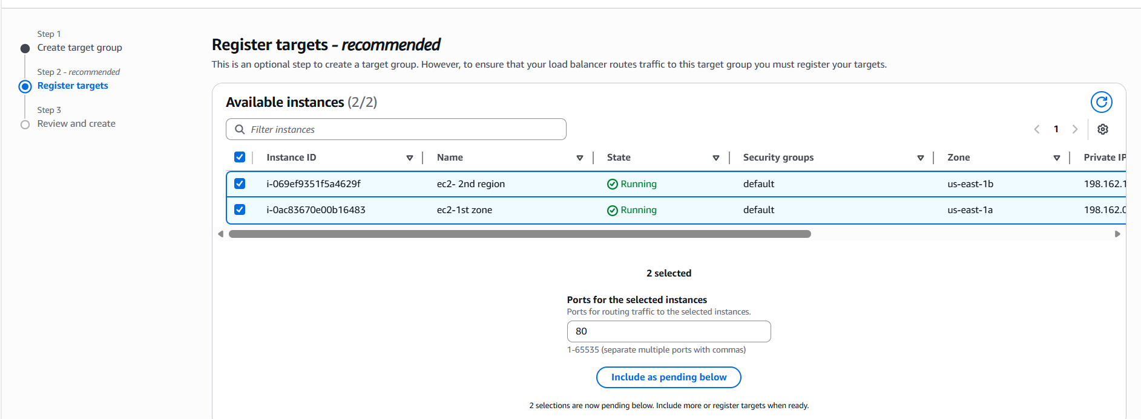

- Target groups successfully created and lets go back to Load balancer and include the Target group.
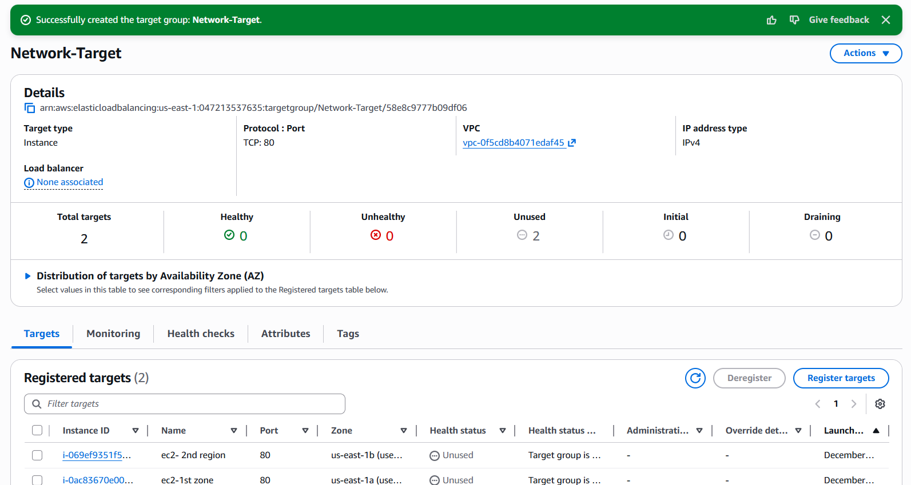

Step 3: Now, back to Load balancer and updated the Target groups to identify the health checks and instances attached.
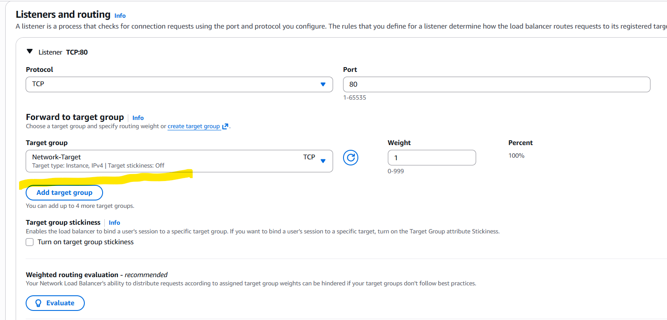

- Network load balancer created successfully.
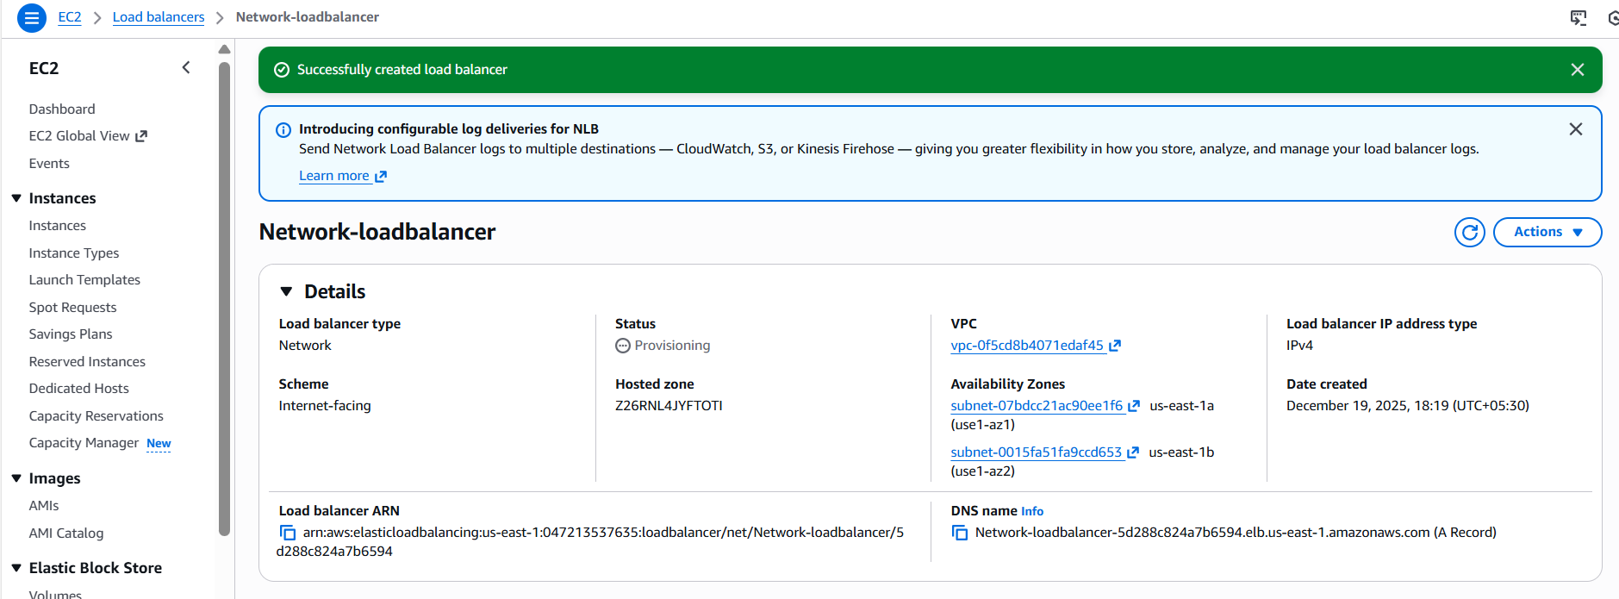

Step 4: We shall verify the DNS in the browser to see if the port is working as expected.
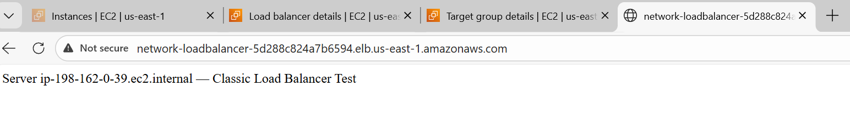
- Two severs are working fine as expected.
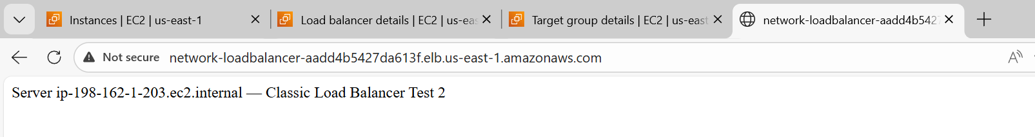

Issues:
There was an issue after Load balancer and Target groups are configured. Inspite of having Healthy checks, the second server wasn’t getting routed. Tried updating the SGs in instance level and Load balancer, tried removing target group and attached, didn’t work.
Finally removed instance from Target group and stopped the instance and restarted the second instance. Then waited for sometime until the target group showed healthy.
Successfully, I was able to verify the second instance getting routed as well.

Conclusion:
Network Load balancer is used when we need high performance and low latency applications to be run on servers. This load balancer is used for liver streaming applications, due to its fast response when connecting to server.

- Configure Application Load balancer.
Objective:
The objective of Application load balancer is to distribute incoming traffic using advanced routing features such as path-based, host-based routing to improve flexibility, scalability and performance of the application.
If my requirement requires advanced routing such as path-based, host-based, ALB is the perfect option to choose.
Prerequisites:
- EC2 instances
- VPC with subnets already created
- Security groups allowing traffic for application port
- Target groups created for HTTP/HTTPS routing
- Health check endpoint available. (/ health)
- IAM permissions to manage ALB and target groups
Step by step Implementation:
Step 1: Earlier we have created NLB and CLB with application Apache installed, so we shall directly start with creating ALB.
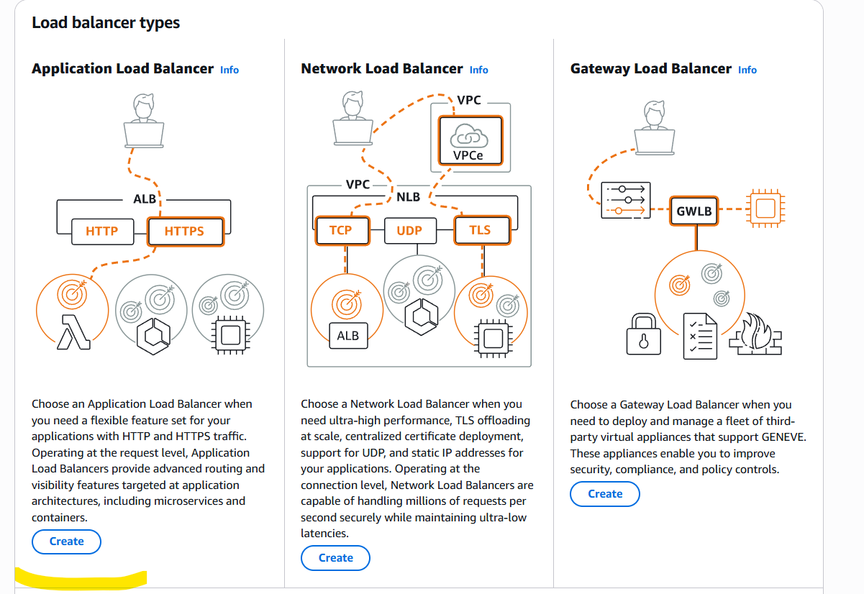
- Created ALB name as Application-load balancer and Scheme as Internet-facing.
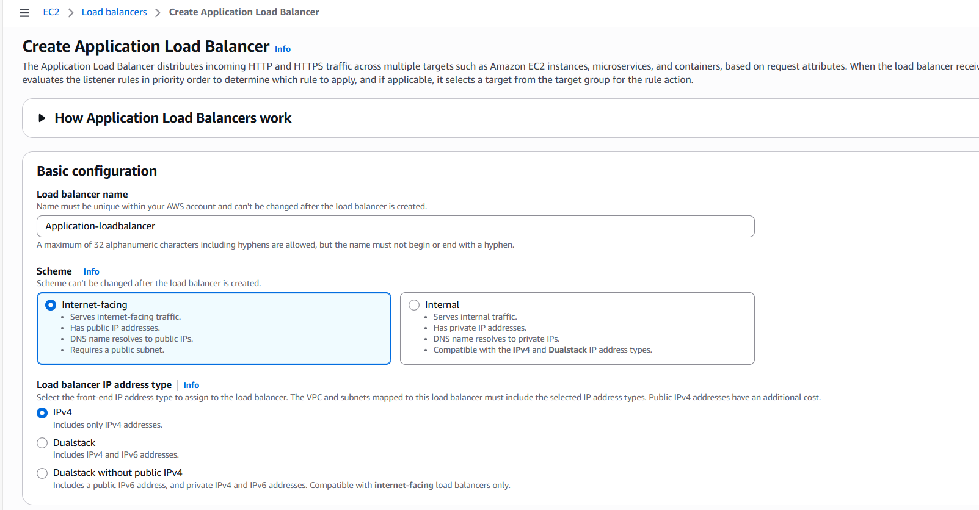
- Listeners port number is 80 for my application Apache.
- Now, its time to navigate to Target groups to attach in ALB.
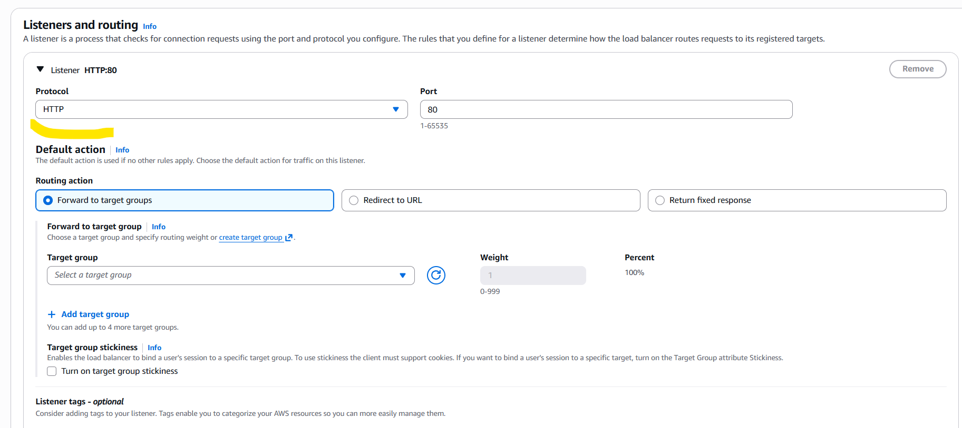

- Navigated to Target groups and named Application-load balancers and scheme will be Internet-facing.
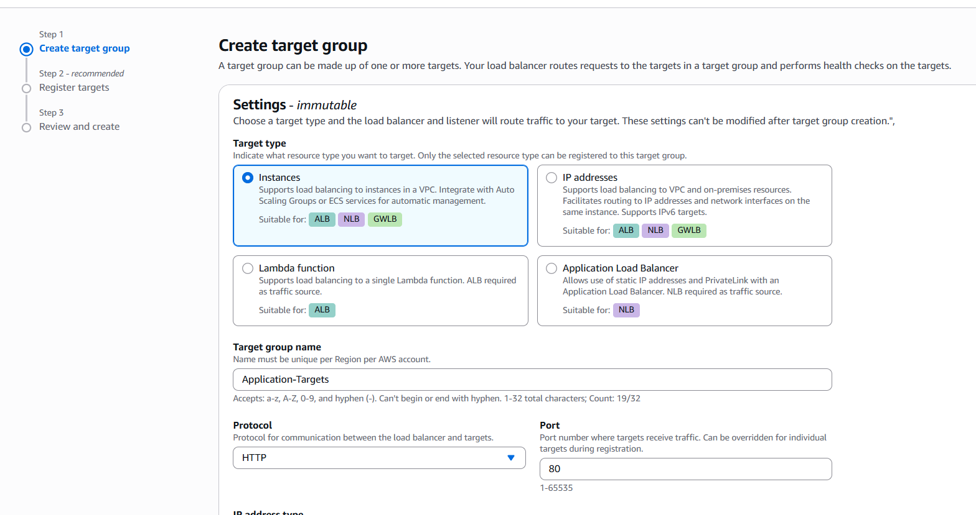
- Protocol port is 80 for my application and VPC is attached to the TG.
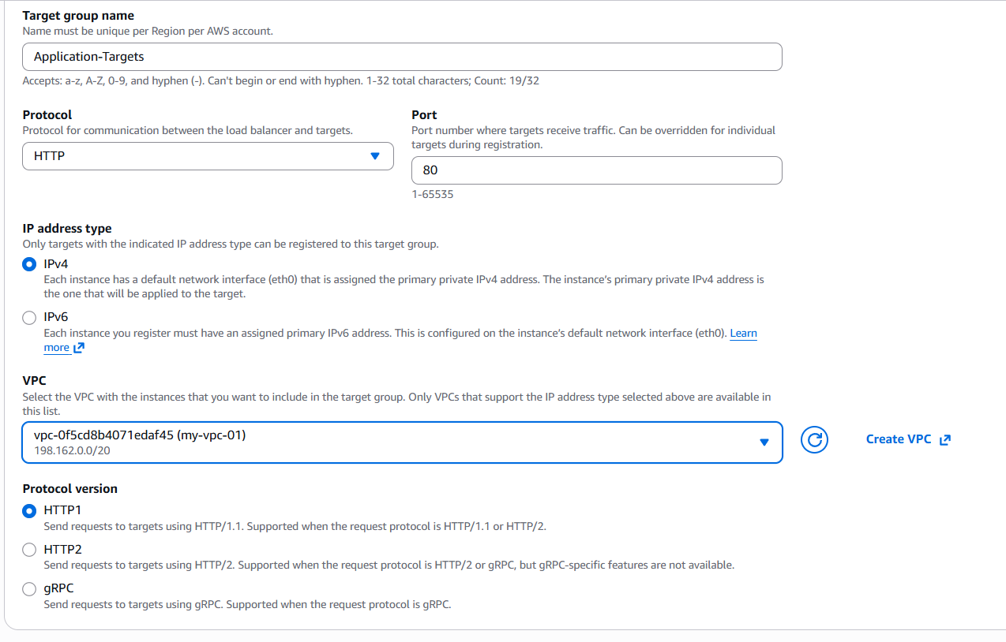
- Health Checks will be default.
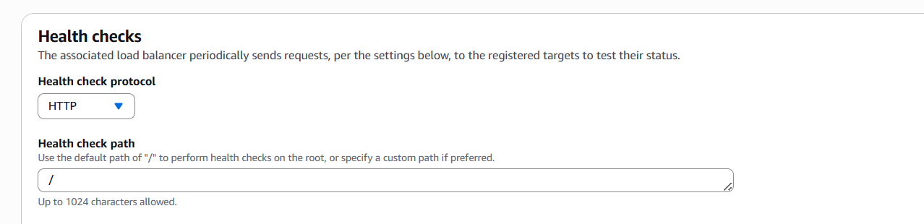
- Instances has been selected and marked as review pending.
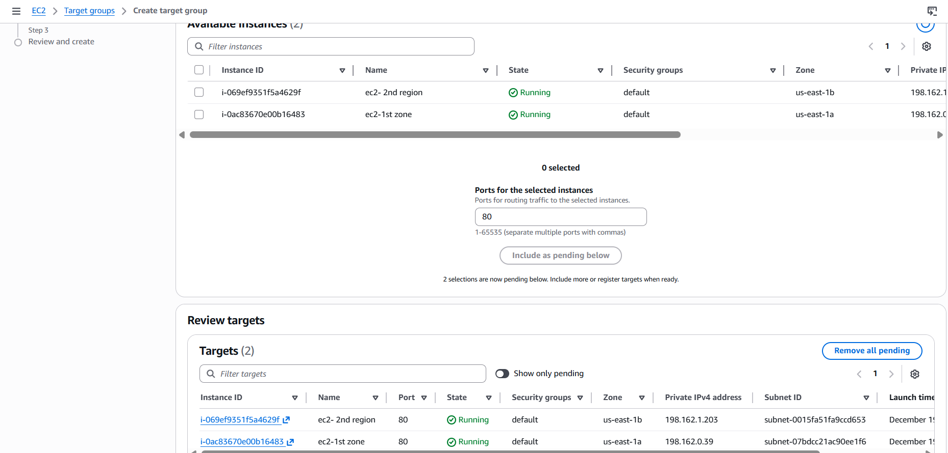
- Target groups successfully created.
- Now let’s attach the Target groups to Application load balancer.
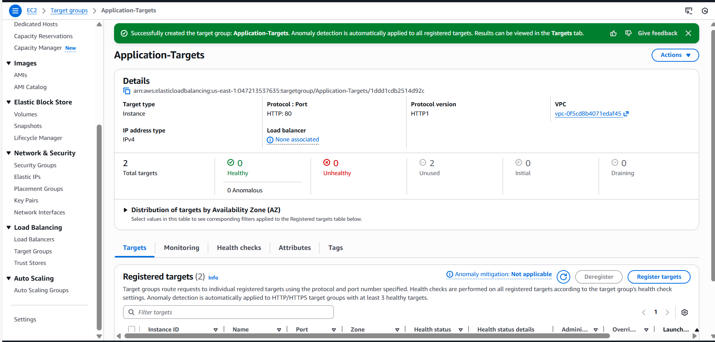

- Attached the Target groups to my ALB.
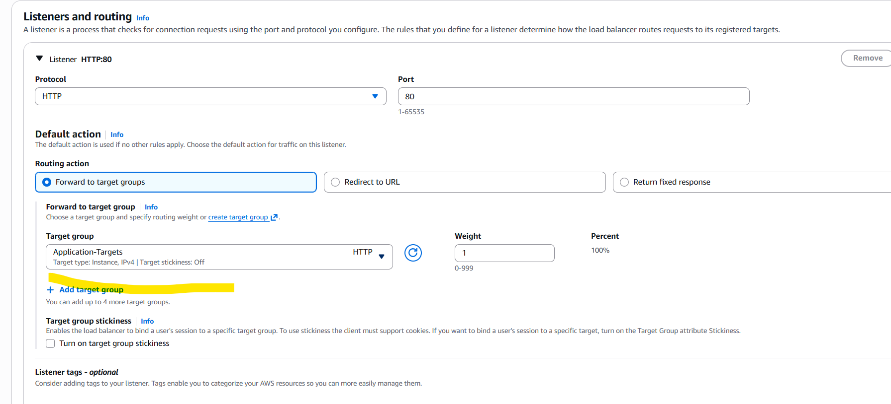
- ALB is successfully created.
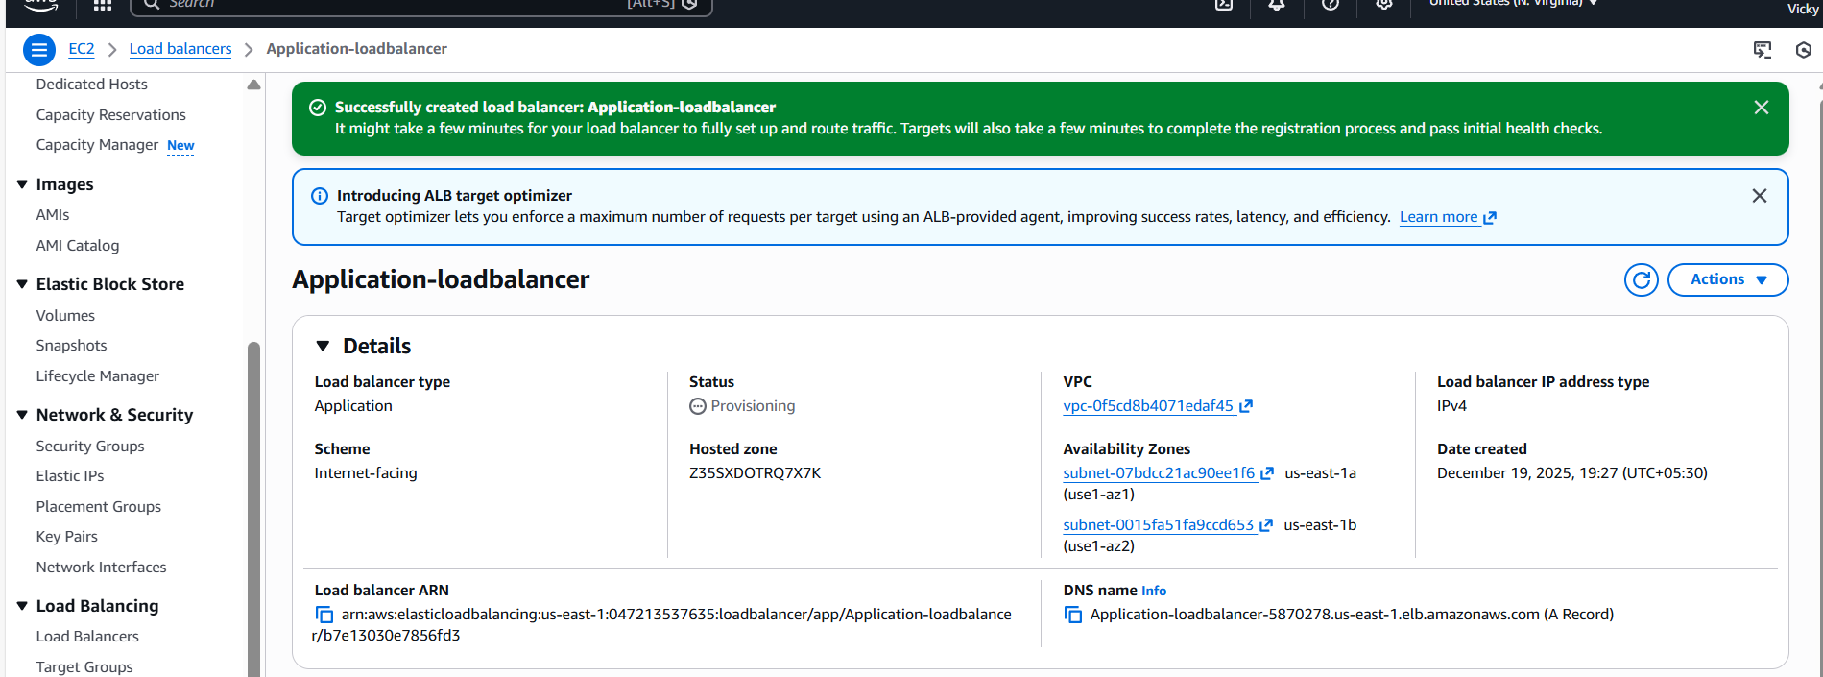

- Now, its’ time to verify the DNS in browser.
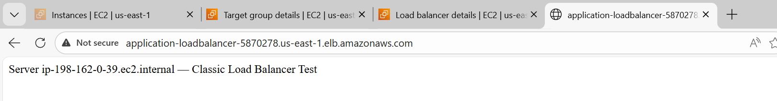
- Both severs are running as expected.
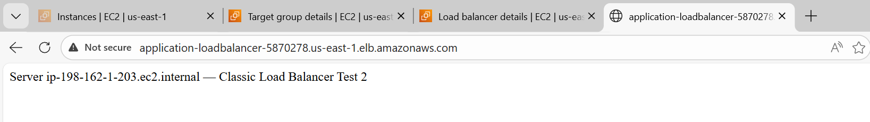

Conclusion:
Application load balancer is used for modern web services that works on OSI model layer -7 routing for high flexibility, scalability which supports HTTP/HTTPS. This load balancer supports more features than Network/Classic and a recommended one for web applications.

- Attach SSL for application load balancer.
- Map Application load balancer to R53.
Objective:
The objective of this task is to enable secure port of connection, whereas its 443 by attaching an SSL certificate from ACM (Amazon certificate manager), so that all incoming traffic is encrypted and paddle lock for secure connection at load balancer.
The motto is to protect our websites and applications with HTTP port.
Using the SSL, our users will have secure user login and data confidentiality.

Prerequisites:
- Application Load balancer in active state
- Route 53, if Domain is created and hosted in aws
- Third party Domain server- GoDaddy
- ACM for SSL certificate
- Target group for decryption traffic.

Step by step Implementation:
Step 1: We have Application Load balancer created and ready, so we shall navigate to GoDaddy and verify the DNS in active state.
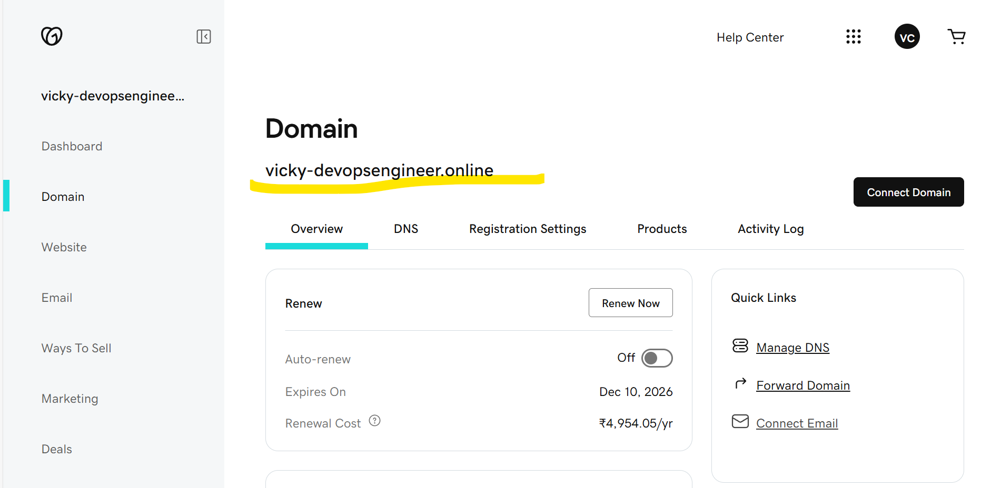

Step 2: Navigate to Route53 and host the services.
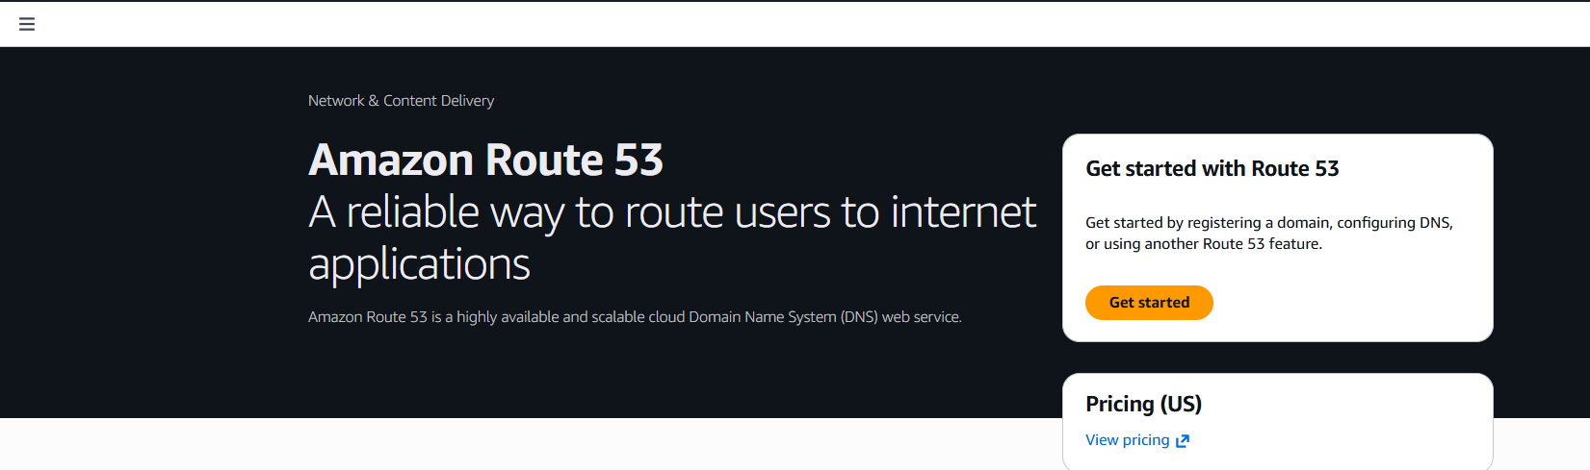
- Here, we are hosting our domain in R53, because we have created our Domain in GoDaddy.
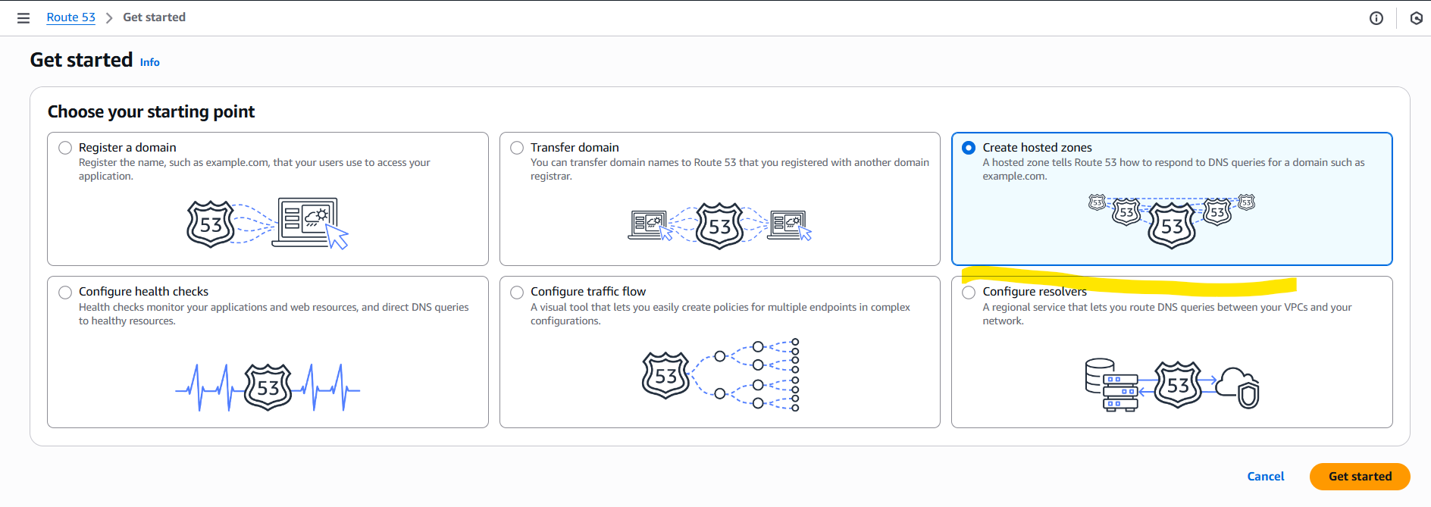

- Created hosted zones in R53 with Domain name same as GoDaddy.
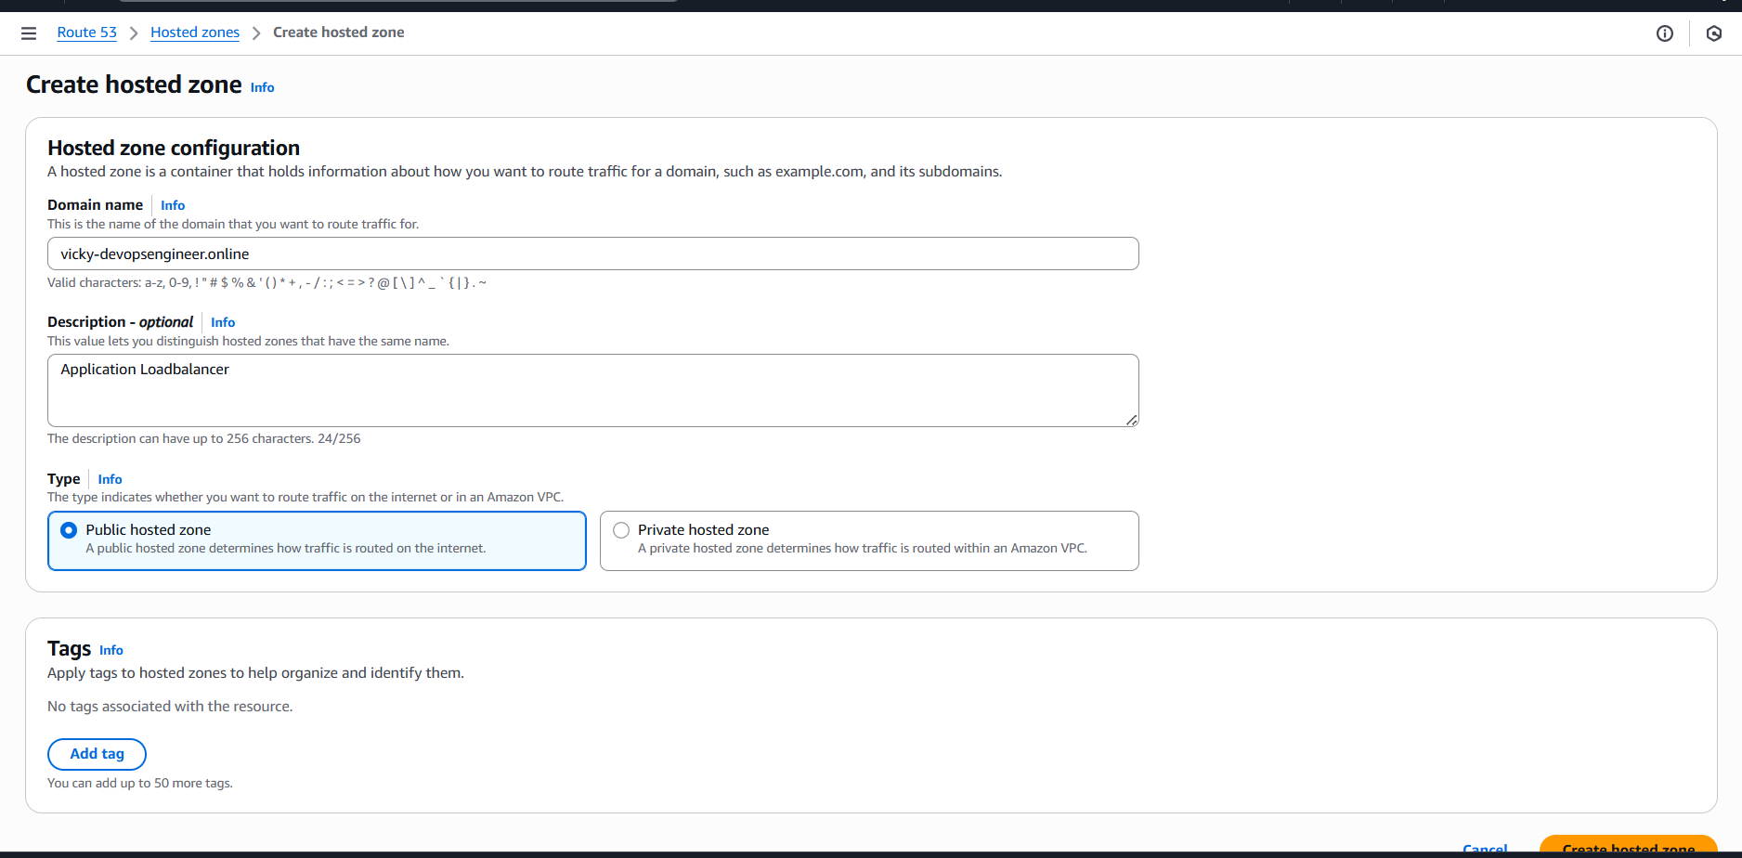
- Our Domain has been hosted in R53, now, lets copy the Name servers and paste in GoDaddy NS.
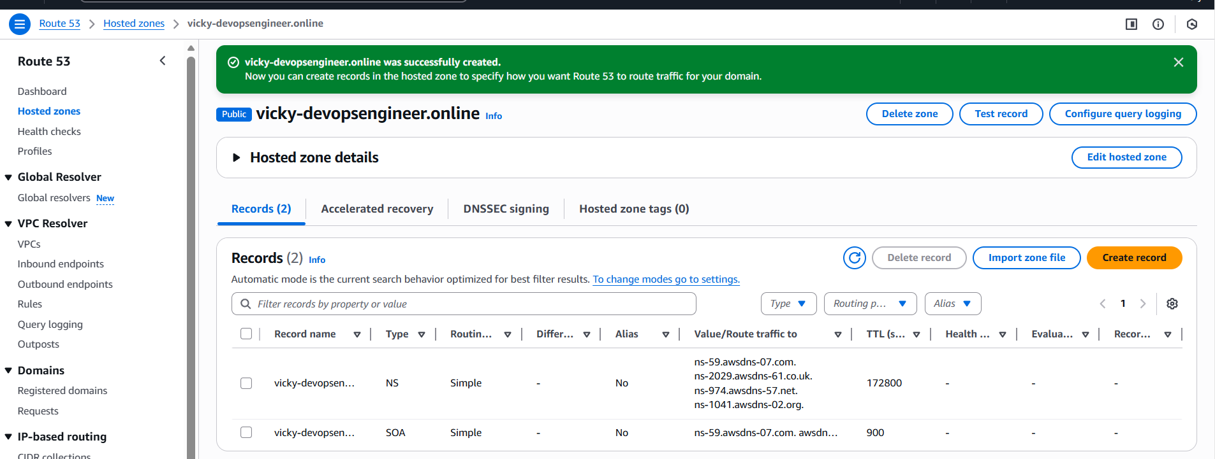
- Updated the Name severs in GoDaddy same as R53.
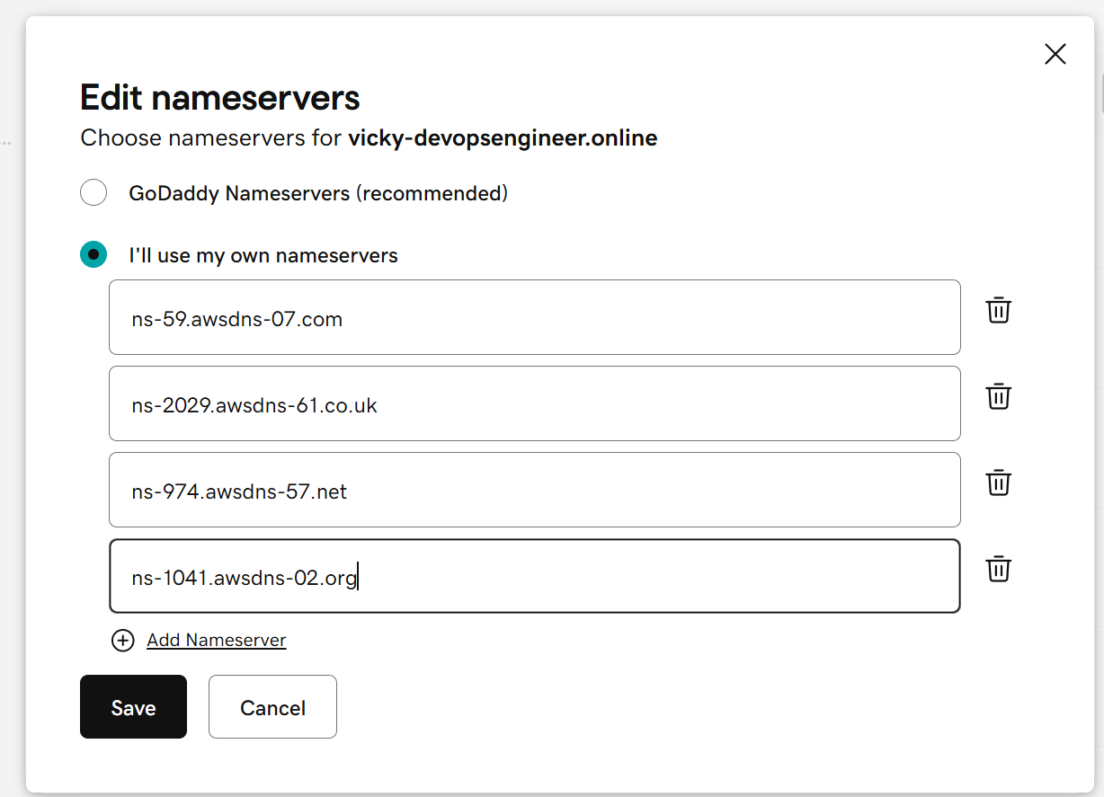

Step 3: Navigate to ACM to obtain the SSL certificate.
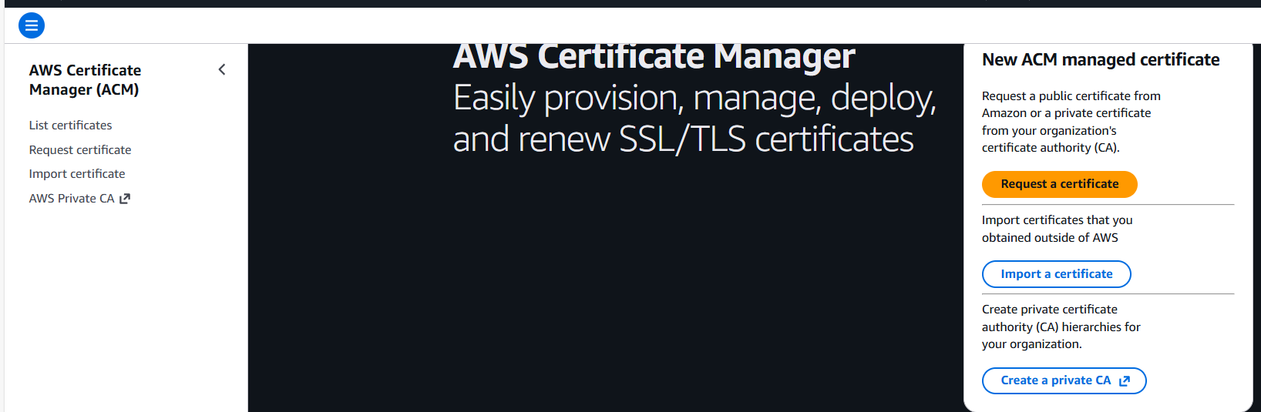
- Updated our Domain name to match in ACM as well.
- Enabled the export and Validation is required.
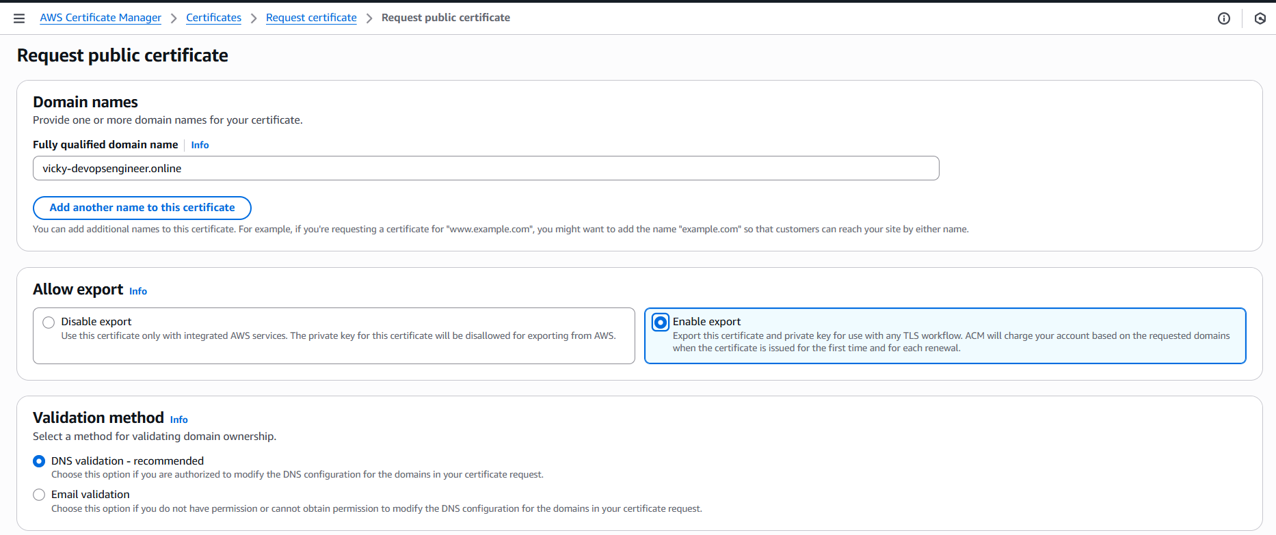
- We have created the ACM certificate and waiting to receive from Amazon.
- While we wait, there is one mandatory step to do, that’s we need to copy the CNAME code ands paste in R53, them Amazon verifies and provides SSL immediately.
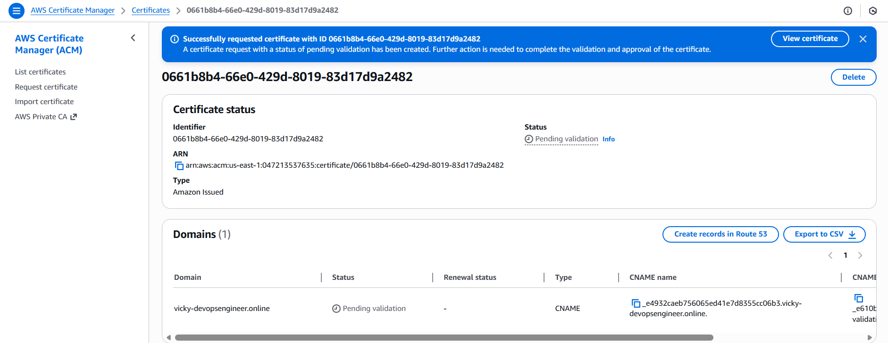
- We have created a new record in R53 for CNAME, which Amazon provided for confirmation.
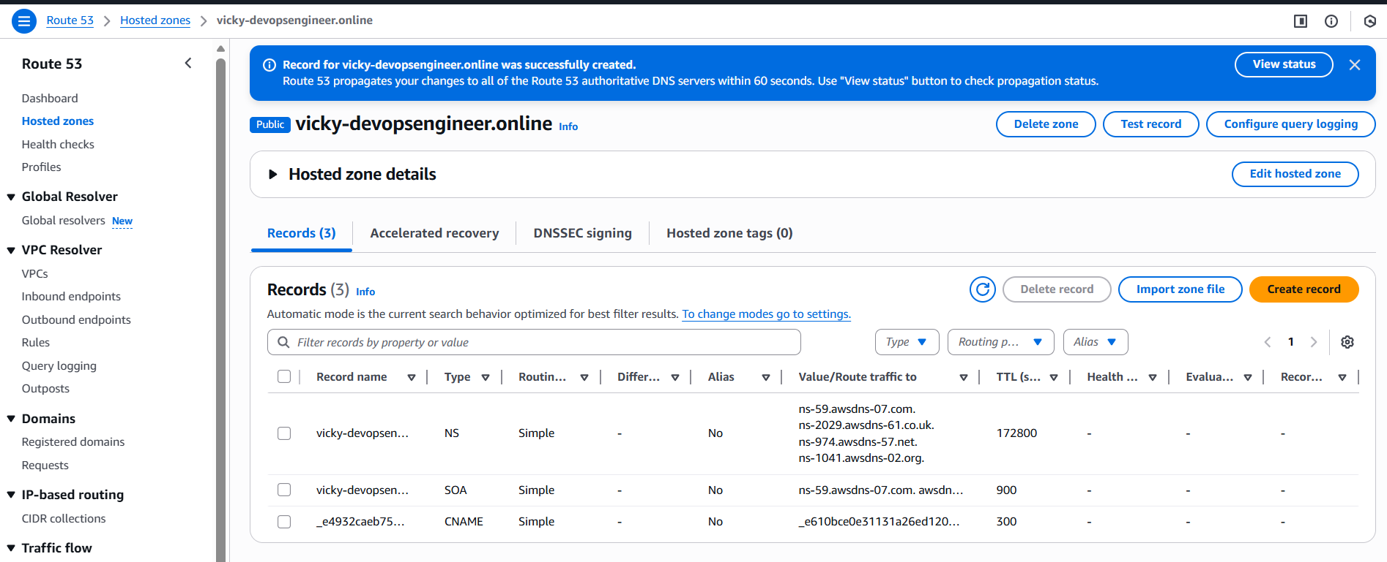
- Amazon to provide the SSL certificate, it takes time, so we went ahead and created record A and enables Alias and select the load balancer.
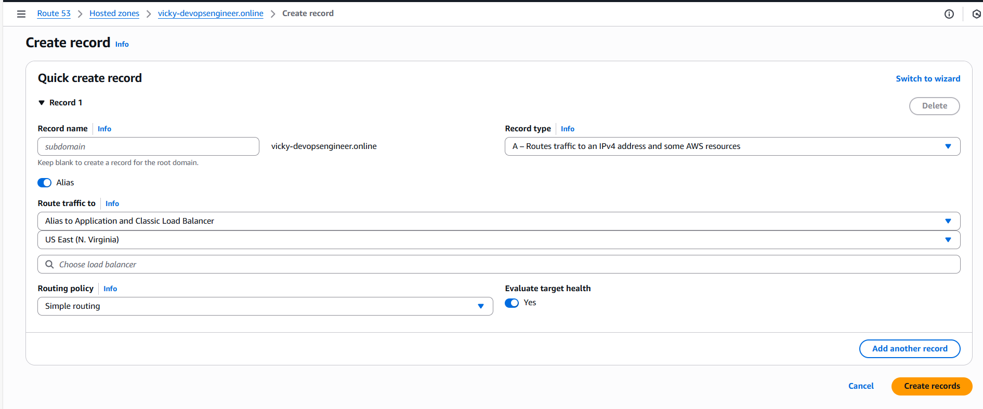

- SSL certificate issued after such a long time.
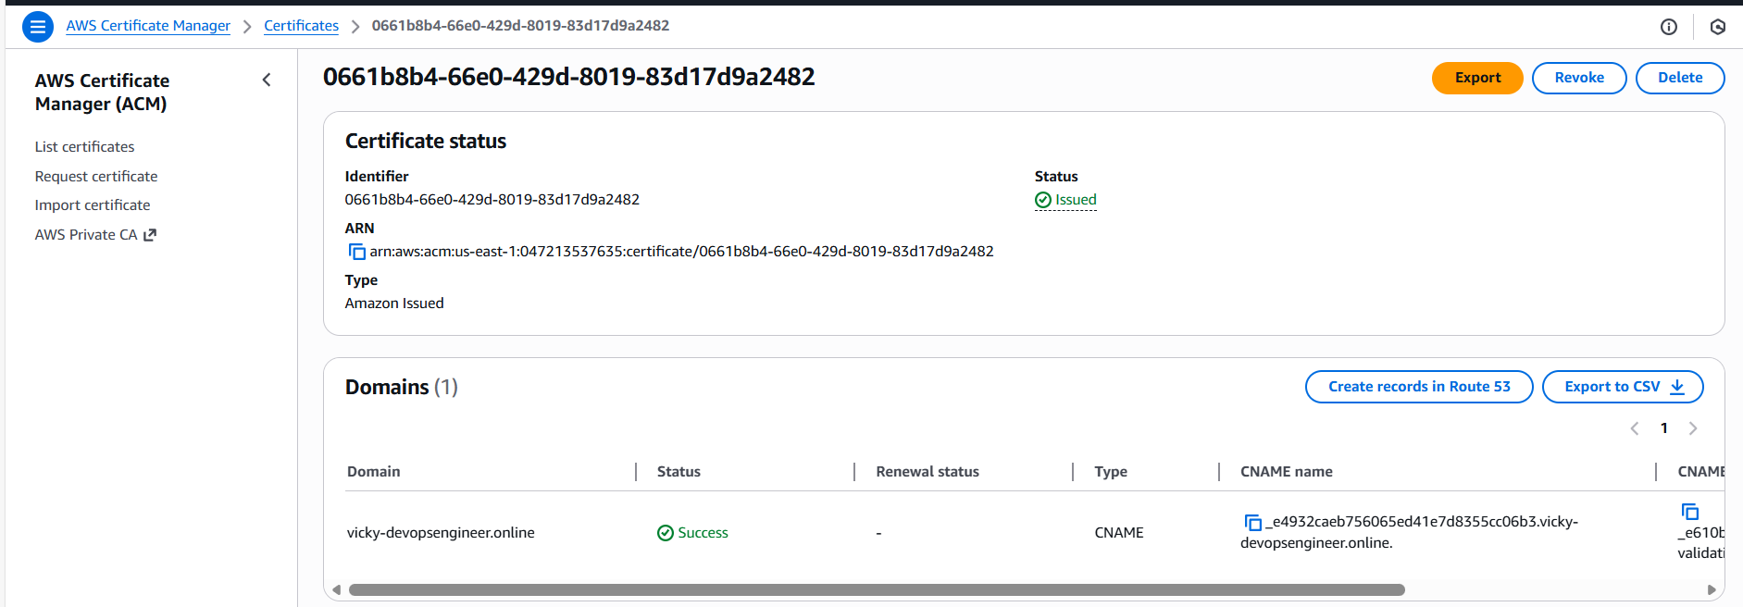

Step 4: We shall navigate to ALB and add our HTTPS port 443.
Updated protocol to HTTPS/4443
Created new Target groups and provided port 443
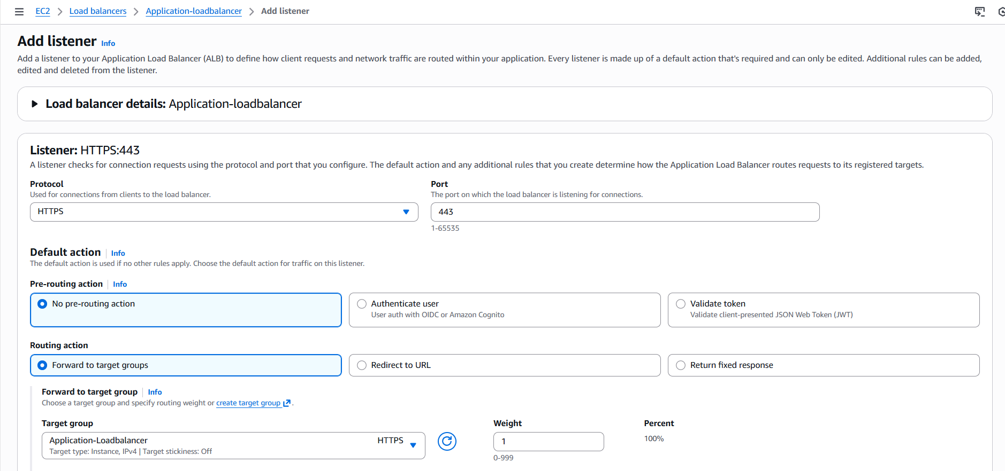

- In the Secure Listener settings, we updated the ACM and attached SSL certificate.
- Now, we will have our website secure and traffic will get distributed accordingly.
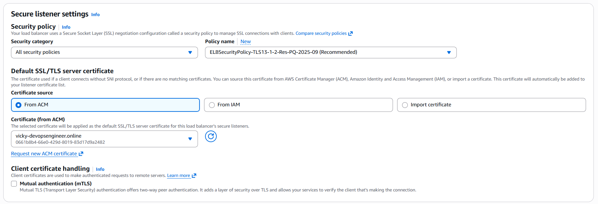
- Successfully updated the ALB.
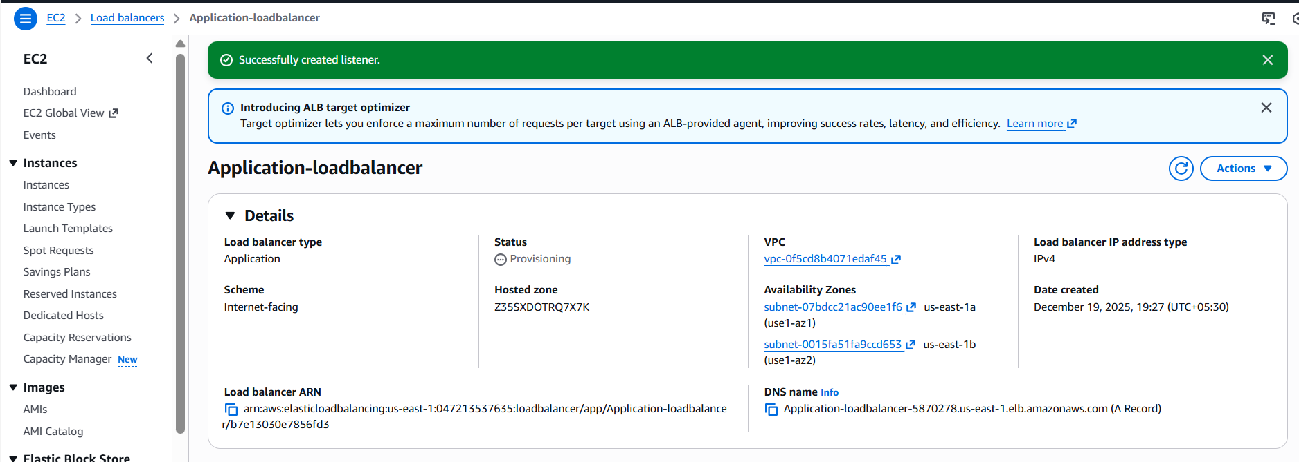

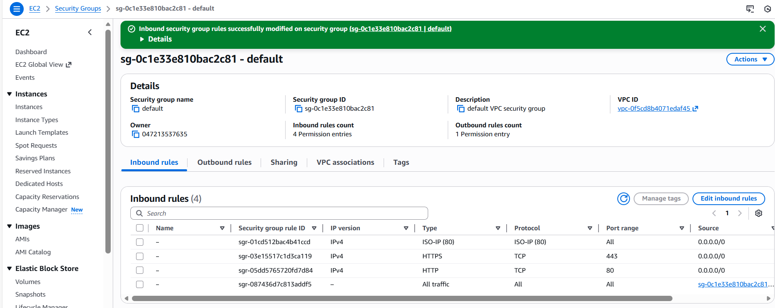

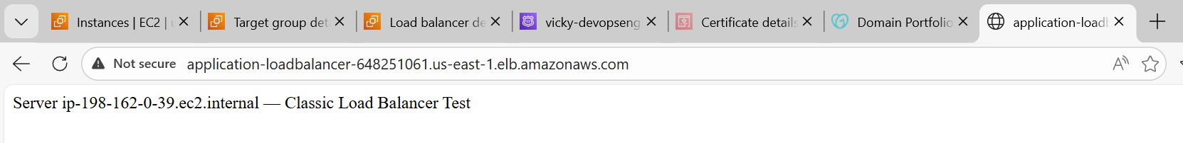
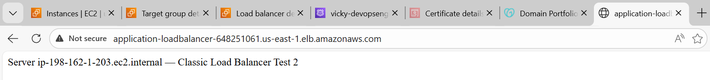

Conclusion:
Once SSL certificate received from Amazon, we should include in Load balancer and create a port for HTTPs and use the DNS to verify.
In my case, I had some issues, after hours of trouble shooting, yet, I couldn’t figure out after updating the SG’s as well.

- Push the application load balancer logs to S3.
Objective:
The objective of this task is to enable and configure ALB logs to be sent to S3, so that traffic logs are automatically delivered.

Prerequisites:
- ALB (created in past)
- S3 bucket
- Json policy
- Attributes in ALB
- IAM permissions.
Step by step Implementation:
Step 1: Navigate to S3 and create a bucket.
Bucket created successfully.
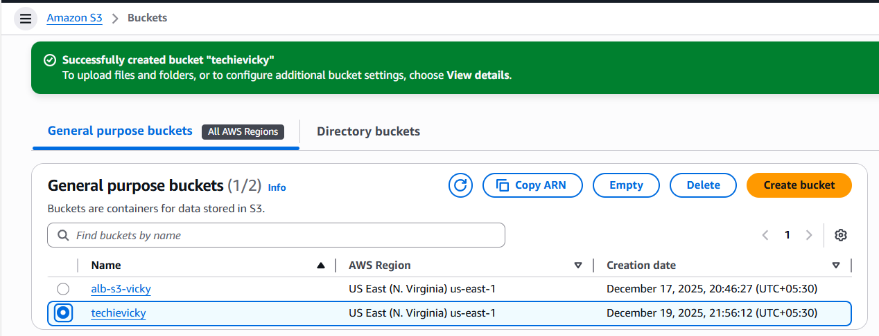

Step 2: Navigate to permissions tab in the created S3 bucket and update the below script to ensure the logs are automatically updated.
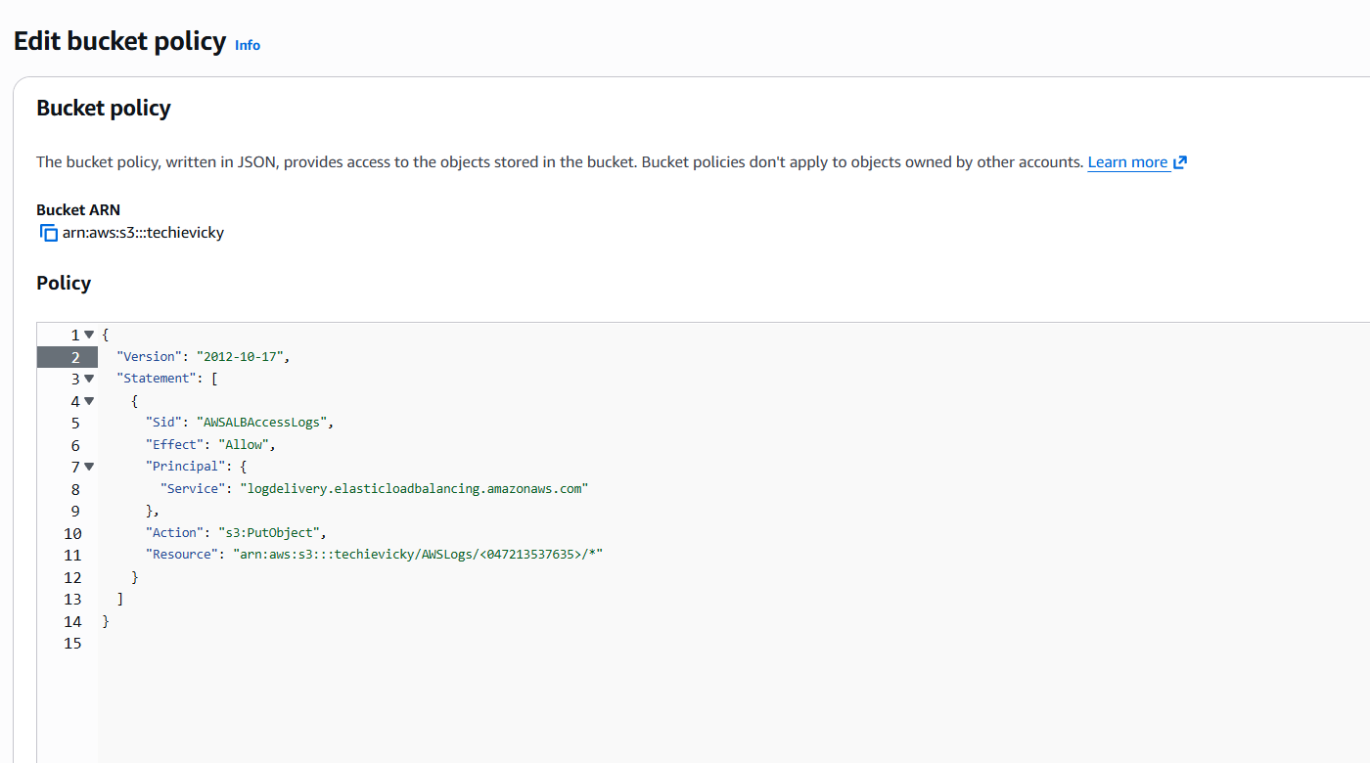
{
"Version": "2012-10-17",
"Statement": [
{
"Sid": "AWSALBAccessLogs",
"Effect": "Allow",
"Principal": {
"Service": "logdelivery.elasticloadbalancing.amazonaws.com"
},
"Action": "s3:PutObject",
"Resource": "arn:aws:s3:::techievicky/AWSLogs/<ACCOUNT-ID>/*"
}
]
}

Step 3: Navigate to Application load balancer and scroll to the tab- Attributes and scroll down to update the S3 logs.
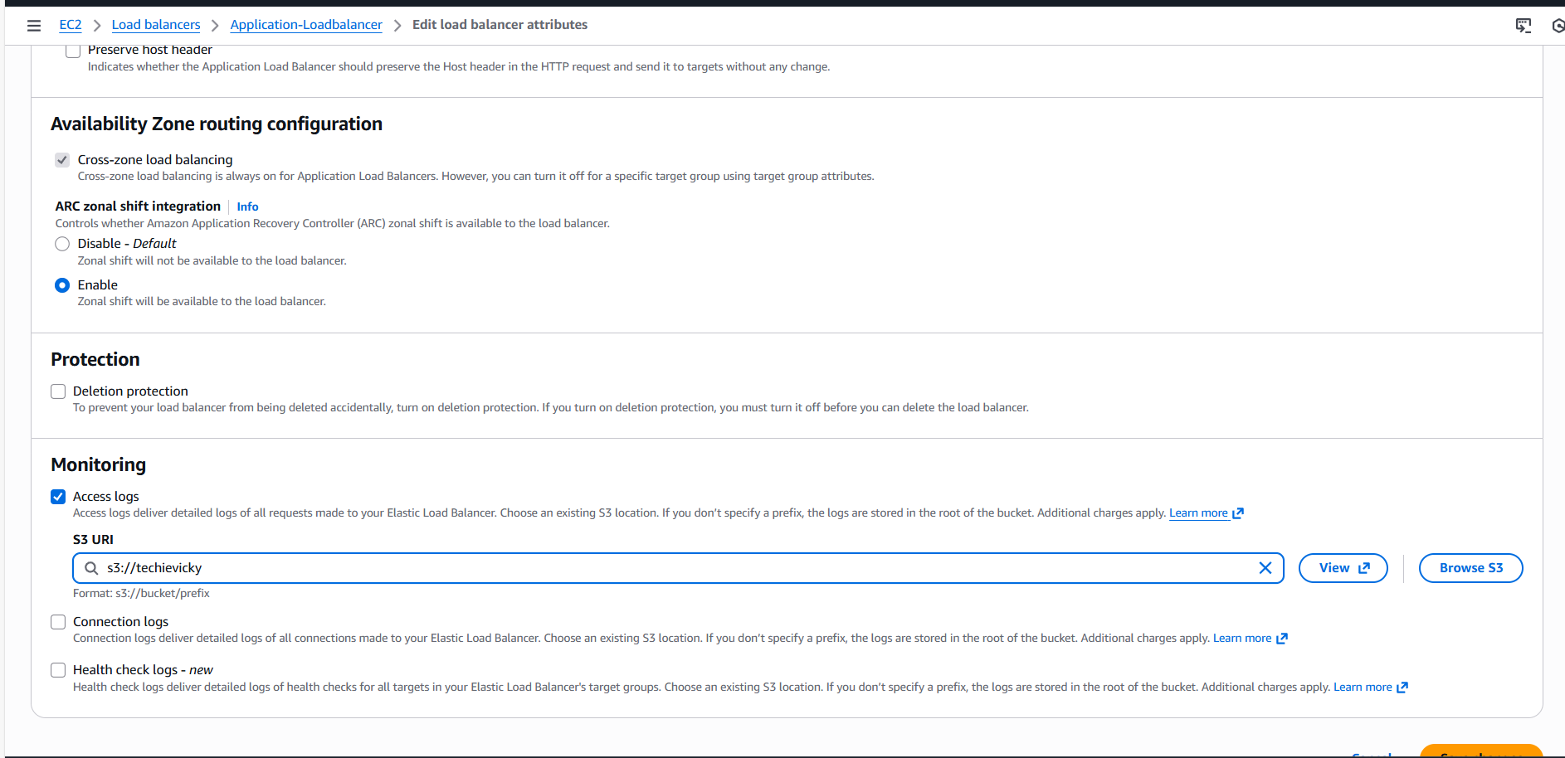
- Finally, we were able to allow the policy to send the access logs to S3 automatically.
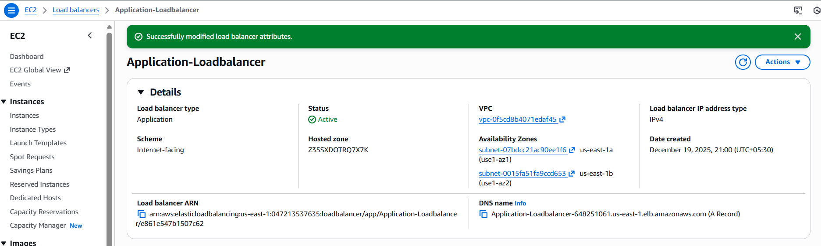

- Success- We can see the access logs are sent to S3.
